**Wheels in Motion: A Comprehensive Examination of Four-Wheeled Traffic Trends across Ireland and Europe (2016-2021)**

**MSC Data Analytics CA2**

*Author: Simone Finelli*

*Student ID: sba22524*

*E-mail:* [*sba22524@student.cct.ie*](mailto:sba22524@student.cct.ie)

*Github:* [*sifine/CA2-Transport_in_Ireland (github.com)*](https://github.com/sifine/CA2-Transport_in_Ireland)

*MSc in Data Analytics*

*Programming for Data Analytics, Statistics for Data Analytics, Machine Learning for Data Analysis, Data Preparation & Visualisation for Data Analytics*

*David Gonzalez, Marina Iantorno, Muhammad Iqbal, David McQuaid*

*CCT College*

*Dublin, Ireland*

**Abstract**

This paper comprehensively explores the dynamics of four-wheeled traffic trends, with a specific focus on Ireland in comparison to other European countries, spanning the period from 2016 to 2021.

The findings not only spotlight unique characteristics within Irish four-wheeled traffic but also establish connections and distinctions with analogous European nations. Notably, the study delves into the intricate relationship between bus and passenger car traffic, offering valuable insights into the roles of public and private transportation modes.

Through the utilization of historical data, this study also introduces a forecasting model designed to predict future trends in four-wheeled traffic.

**Table of Figures**

Figure 1. IRF data warehouse6

Figure 2. Data load and merge 8

Figure 3. Dataset info, describe and shape9

Figure 4. Unique countries 10

Figure 5. Total four wheeled traffic by year for Belgium 10

Figure 6. Total four wheeled traffic by year for Monaco 11

Figure 7. Total four wheeled traffic by year for Belarus 11

Figure 8. Total four wheeled traffic by year for Austria 12

Figure 9. Boxplot for each feature and country over time 12

Figure 10. Boxplot for each feature in Croatia over time 13

Figure 11. Boxplot for each feature in Finland over time 13

Figure 12. Dataset head 14

Figure 13. Dataset rows with total sum mismatch 15

Figure 14. Dataset rows with total sum mismatch considering 1% margin 15

Figure 15. Dataset rows with NaN values 16

Figure 16. Bus and motor coach traffic by year for Austria 16

Figure 17. Food Value over time. See the location nine value in the top right  17

Figure 18. Bus and motor coach traffic by year for Belarus 17

Figure 19. Bus and motor coach traffic by year for Belgium 18

Figure 20. Quick dataframe check after MinMaxScales 18

Figure 21. Boxplot comparison for Croatia to show how scaling impacted outliers 19

Figure 22. Boxplot comparison for Ireland to see how scaling impacted outliers 19

Figure 23. Boxplot comparison for N. Macedonia to see how scaling impacted outliers20

Figure 24. Boxplot comparison for Slovenia to see how scaling impacted outliers20

Figure 25. Ireland traffic trend over time 21

Figure 26. Ireland traffic metrics boxplots21

Figure 27. Mean, Median, Mode and Standard deviation for Ireland22

Figure 28. Mean, Median, Mode and Standard deviation for EU excluding Ireland22

Figure 29. Bus and Motor Coach Traffic confidence interval in Ireland24

Figure 30. T-test for bus and motor coach traffic mean equal to 5% in Ireland24

Figure 31. Traffic metrics confidence intervals in Ireland25

Figure 32. Ljung-Box test results26

Figure 33. Shapiro-Wilk test results 27

Figure 34. Combination of Ljung-Box, Shapiro-Wilk and Variance tests 27

Figure 35. T-test on bus and motor coach traffic between Ireland and other countries 28

Figure 36. Kruskal test results 29

Figure 37. Wilcoxon test results 30

Figure 38. Combination of Kruskal and Wilcoxon tests results 31

Figure 39. Review dataset creation 33

Figure 40. Number of elements for each class in score 33

Figure 41. Boxplot for each feature in Finland over time 34

Figure 42. Number of elements for each class in score after merging score groups 34

Figure 43. Number of elements for classes after merging and minority sampling 35

Figure 44. Classification report before reducing classes 36

Figure 45. Classification report after minority sampling with CountVectorzer 36

Figure 46. Classification report after minority sampling with TfidfVectorizer 36

Figure 47. Dataset ready for ML 37

Figure 48. Dataset preparation for Linear Regression 37

Figure 49. Simple Linear Regression modelling 38

Figure 50. Linear Regression modelling with hyperparameters tuning 38

Figure 51. Simple Dense Neural Network modelling 39

Figure 52. Simple Dense Neural Network loss graph 39

Figure 53. Simple LSTM loss graph40

Figure 54. Hyperparameters tuned for LSTM modelling40

Figure 55. LSTM with hyperparameters tuning loss graph  40

Figure 56. MSE score table comparison for different models41

Figure 57. Actual vs predicted car traffic in 2021 for best LR and LSTM models41

Figure 58. Actual vs predicted bus traffic in 2021 for best LR and LSTM models42

Figure 59. Actual vs predicted other traffic in 2021 for best LR and LSTM models42

Figure 60. Dashboard with applied filters44

Figure 61. Dashboard without applied filters44

Figure 62. Dashboard with “Show only countries similar to Ireland” checkbox applied45

Figure 63. Dashboard with map visualization45

Figure 64. Traffic metrics confidence intervals in Ireland46

Figure 65. Dashboard with traffic trends visualization and 2020 as selected year47

Figure 66. Dashboard with actual vs predicted values for LSTM and LR models47

Figure 67. Dashboard with traffic metric table48

Figure 68. Dashboard with user reviews table48

**Table of Contents**

Data Preparation & Visualisation – Data acquisition 6

Data Preparation & Visualisation – Exploratory Data Analysis 8

Data Preparation & Visualisation – Preparation for Statistics and ML 14

Statistics – Descriptive statistics 21

Statistics – Inferential statistics 24

Statistics – Parametric and non-parametric inferential statistical 26

Machine Learning – Rationale and justification 32

Machine Learning – Sentiment analysis 33

Machine Learning – Modelling 37

Machine Learning – Evaluation and comparison 41

Data Preparation & Visualisation – Interactive Dashboard 44

Reference List 49

## Data Preparation & Visualisation – Data acquisition

This assessment utilizes traffic data from the International Road Traffic, encompassing various vehicle types and countries.

*The International Road Federation (IRF) is a global, independent, not-for-profit organisation with headquarters in Geneva, Switzerland. Active since 1948, IRF is a membership-based organisation, representing leading corporate and institutional players drawn from the road and mobility sectors worldwide. Its mission is to promote the development of roads and road networks that enable access and sustainable mobility for all. (IRF, 2024)*

To streamline the focus in line with the study's objectives, emphasis is placed on traffic data specific to four-wheeled vehicles in EU countries.

For the coming analysis, it is assumed that four-wheeled transportation of bus vehicles extends coherently to non-four wheeled transportation modes such as trains and trams.

The acquisition of this data required a registration process that then led to the access of the data warehouse:

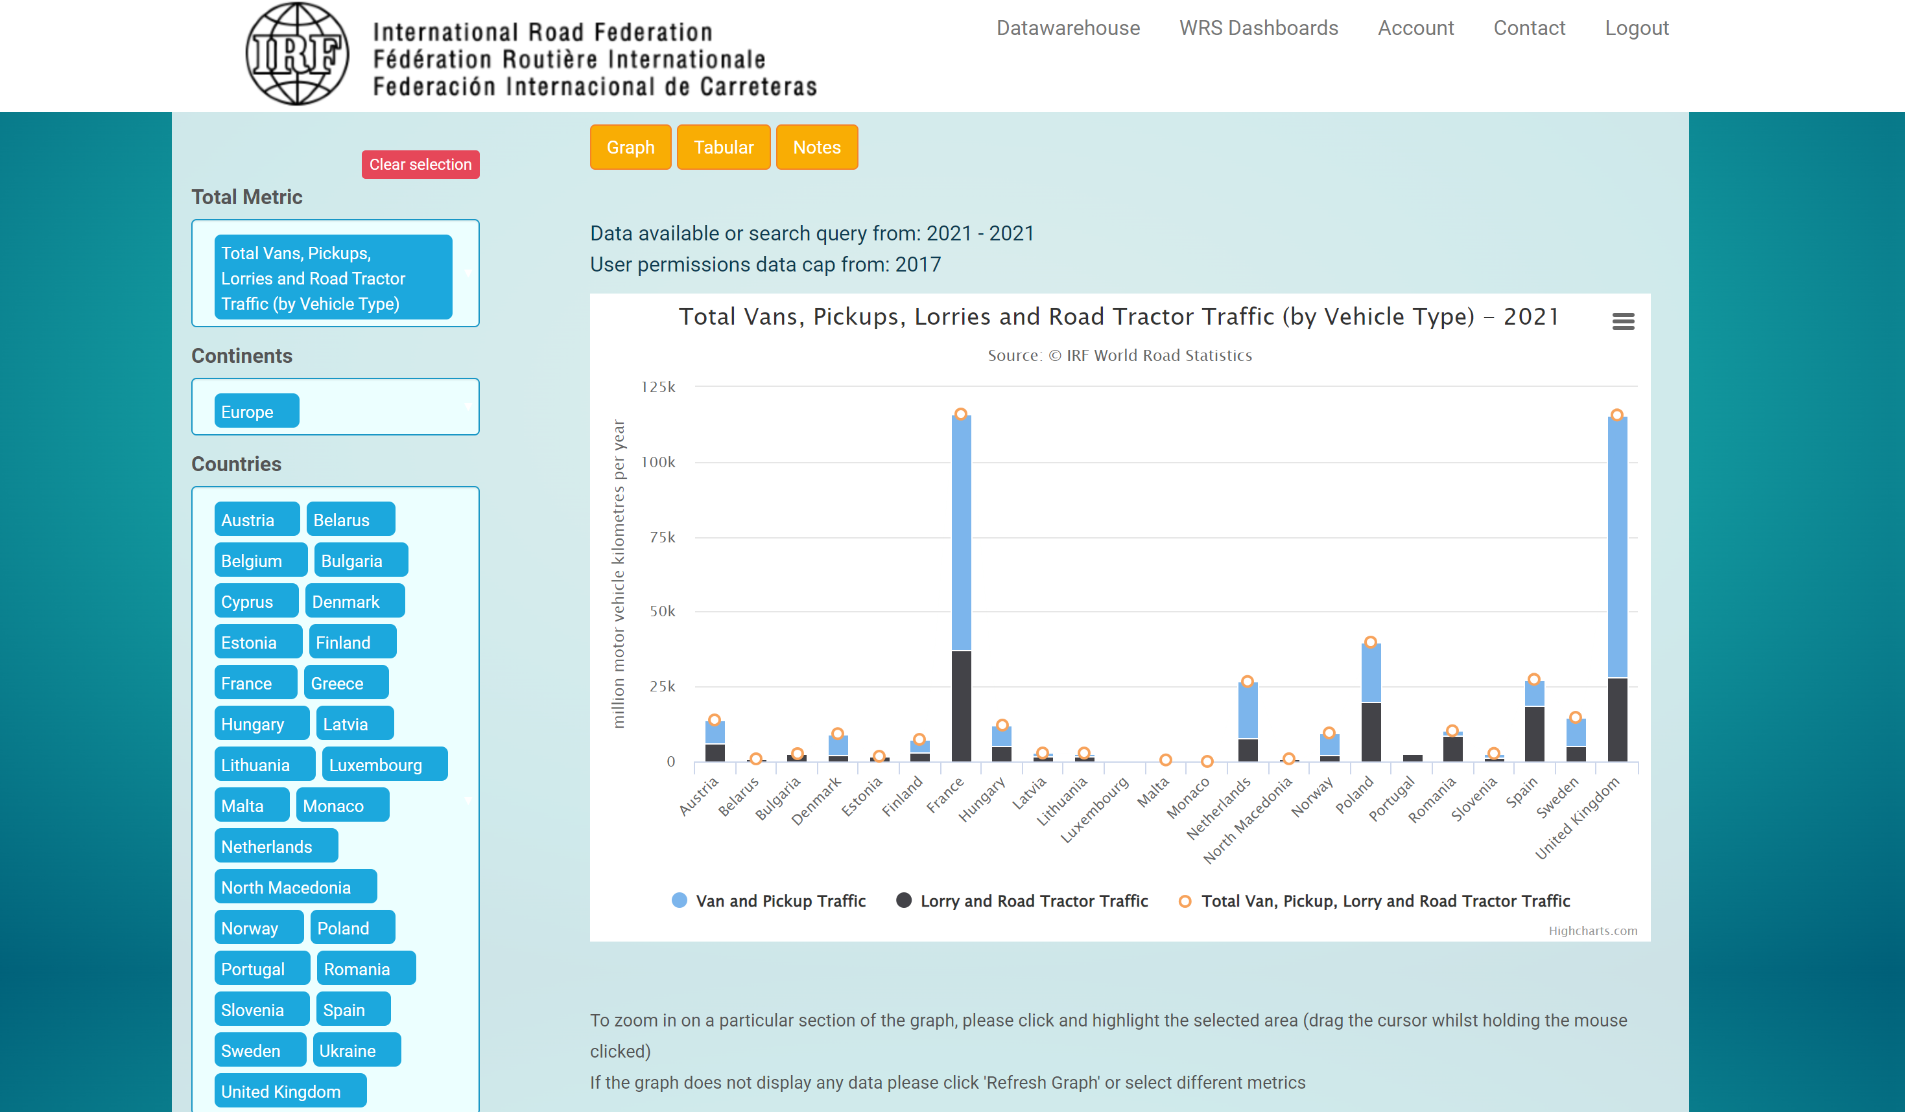

1. *IRF data warehouse*

Looking at the Terms and Conditions we can read:

*1.2 By registering an IRF WRS Data Warehouse Account, you agree that (1.) you will not do anything which would assist anyone who is not a registered user to gain access to the IRF World Road Statistics data, (2.) you will not create accounts for the purpose of abusing the functionality of the site, or other users, (3.) to notify IRF immediately if you become aware of any unauthorised use of your password by others. (World Road Statistics, 2020)*

To comply with this, I therefore require anyone looking into this assessment to register, for free, to the [data source](https://datawarehouse.worldroadstatistics.org/register).

An exchange of emails with the IRF Statistics Team has taken place to notify them regarding the usage of this data for academic purposes only.

## Data Preparation & Visualisation – Exploratory Data Analysis

At first, data was loaded and merged into a single dataframe:

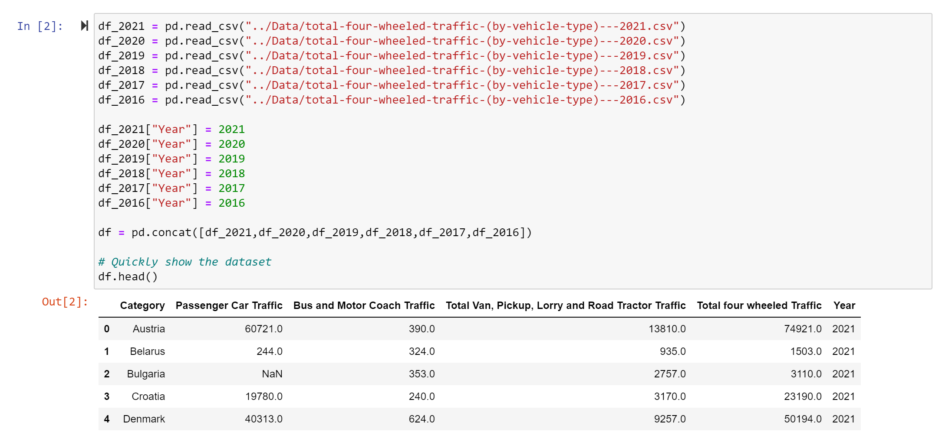

1. *Data load and merge*

The definitions of columns are:

* *Passenger cars are road motor vehicle, other than a motor cycle, intended for the carriage of passengers and designed to seat no more than nine persons (including the driver). Passenger cars include microcars (needing no permit to be driven), taxis, vans designed for transport of passengers and passenger hire cars, provided that they have fewer than ten seats.*
* *Buses and motor coaches are road motor vehicles designed to seat more than nine persons (including the driver). Included are mini-buses and mini-coaches designed to seat more than nine persons (including the driver).*
* *Vans & Pick-ups (Light goods road vehicle) are road vehicles with a gross vehicle weight of not more than 3500 kg, designed, exclusively or primarily, to carry goods, e.g. vans and pick-ups.*
* *Total four wheeled Traffic is just the sum of the previous.*

*(IRF, 2020)*

From the info, describe and shape functions we get:

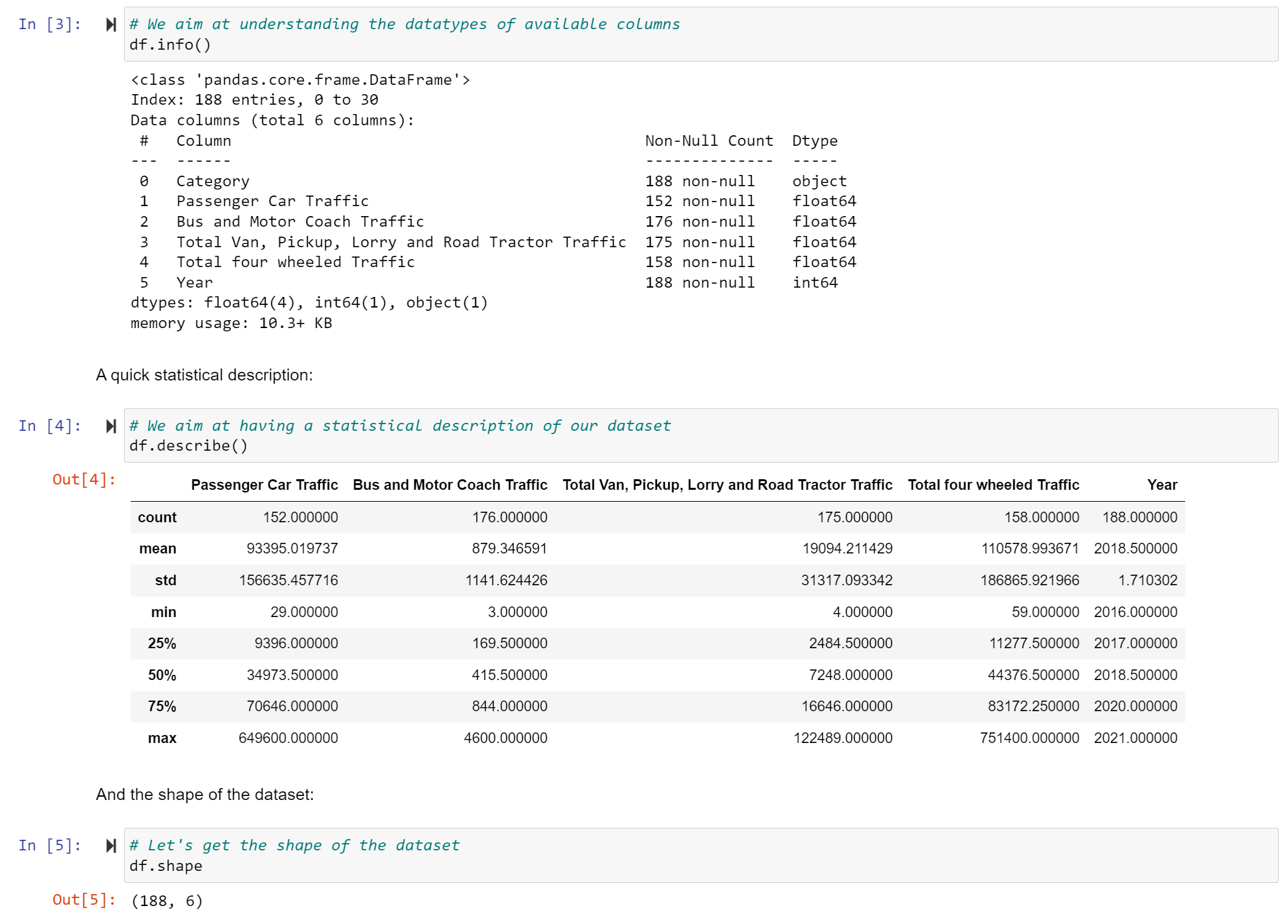

1. *Dataset info, describe and shape*

This leads us to the following conclusions:

* our dataset is made of 6 columns and 188 rows.
* The six columns are all numerical except for the Category one that represents the name of the country.
* Each row shows the traffic metrics of a specific country each year.

From the descriptive statistics we can already see min and max values for different traffic metrics.

Because compared countries can be very different between each other, traffic data can vary significantly. For this reason, we will consider percetnage of traffic metrics with respect to the total four wheeled traffic.

Unique countries are below represented:

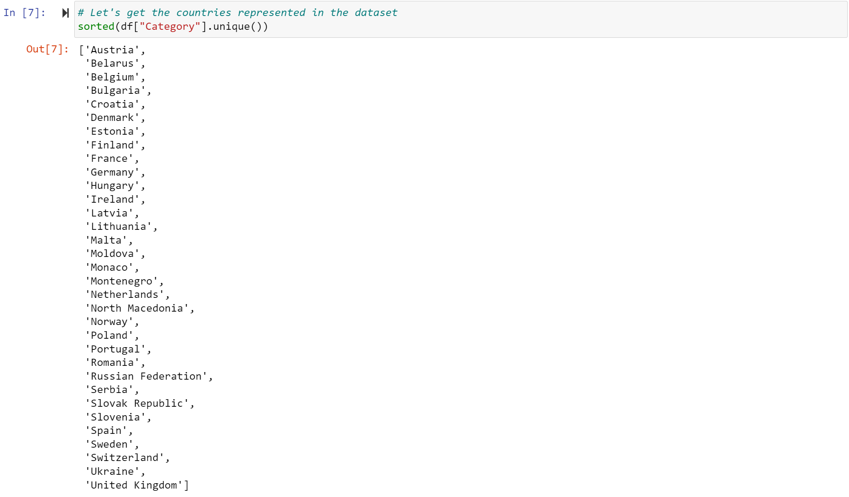

1. *Unique countries*

But with a quick dash app we can see that some of the countries are missing data for specific metrics and/or years:

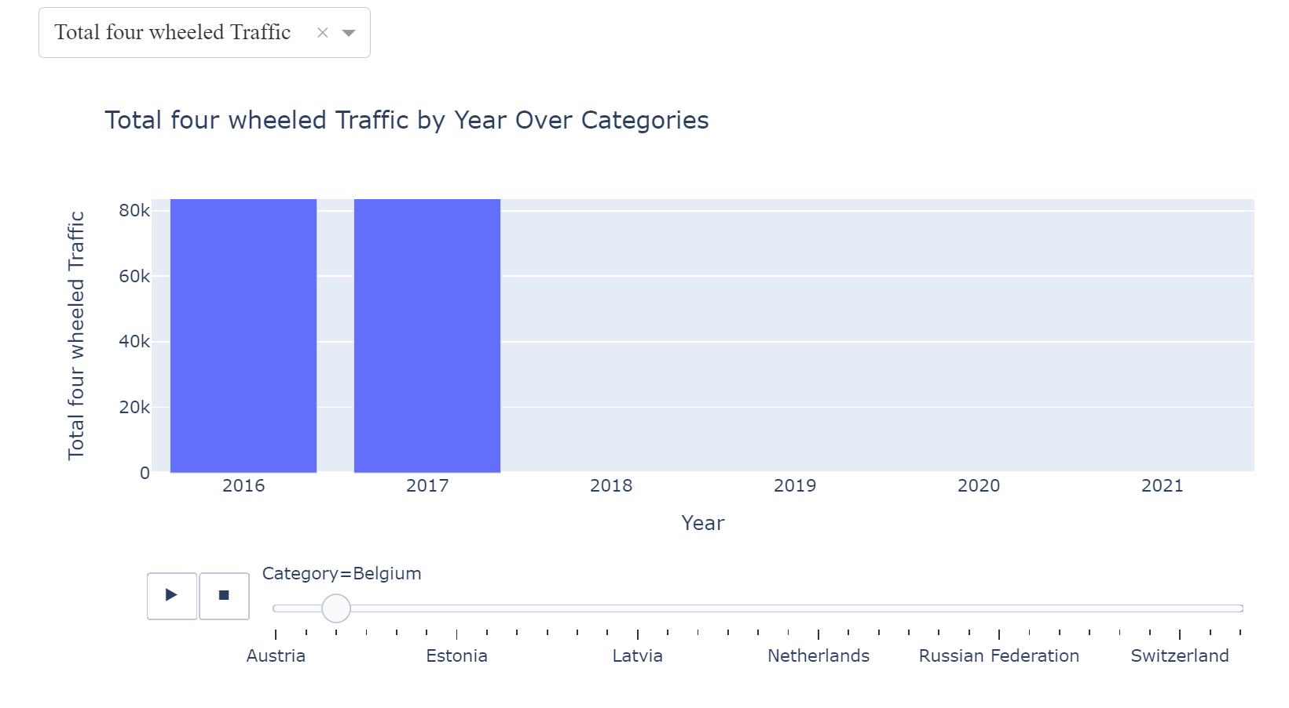

1. *Total four wheeled traffic by year for Belgium*

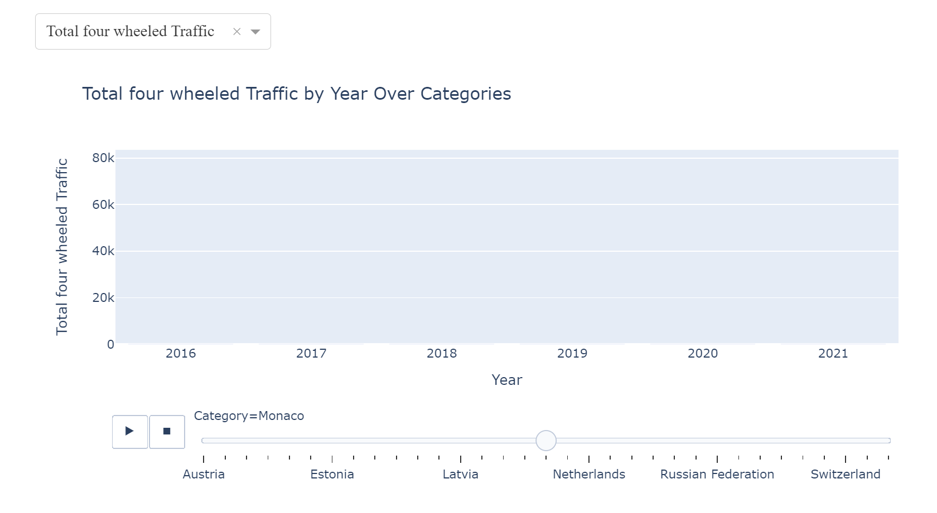

1. *Total four wheeled traffic by year for Monaco*

Also, we can see that there is a high unbalance, making even more necessary to work with percentages:

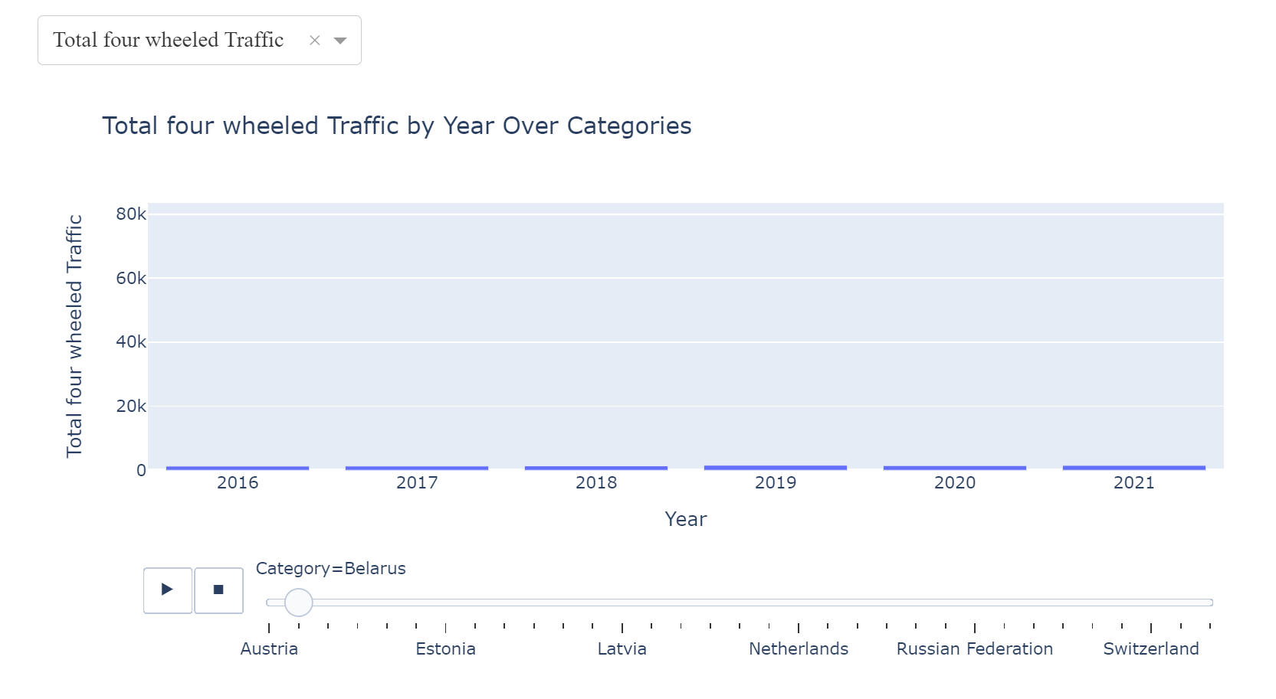

1. *Total four wheeled traffic by year for Belarus*

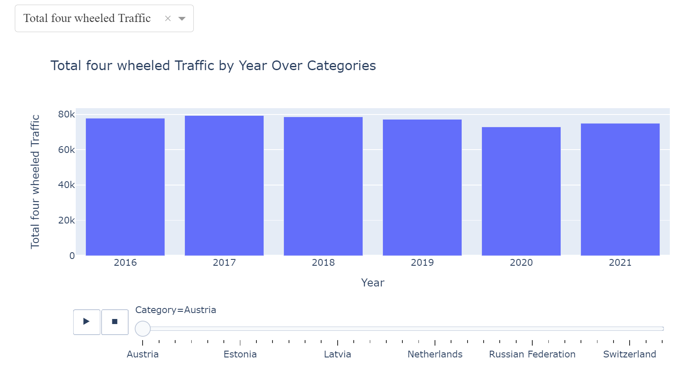

1. *Total four wheeled traffic by year for Austria*

This last statement is also confirmed if we look at boxplot graph:

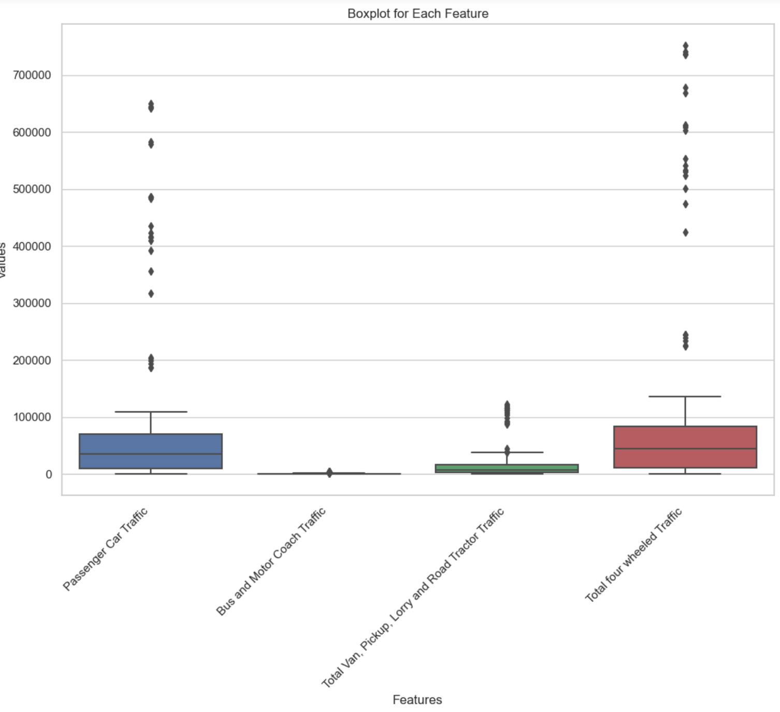

1. *Boxplot for each feature and country over time*

If we look at countries as an aggregation between years at features level, many outliers can be visible. Possible reasons are:

* Outliers could be only few countries behaving as outliers for multiple years.
* As data is not scaled, this might be the cause of many outliers.

If we instead look at single countries, we can agree that most of outliers are caused by the need of scaling:

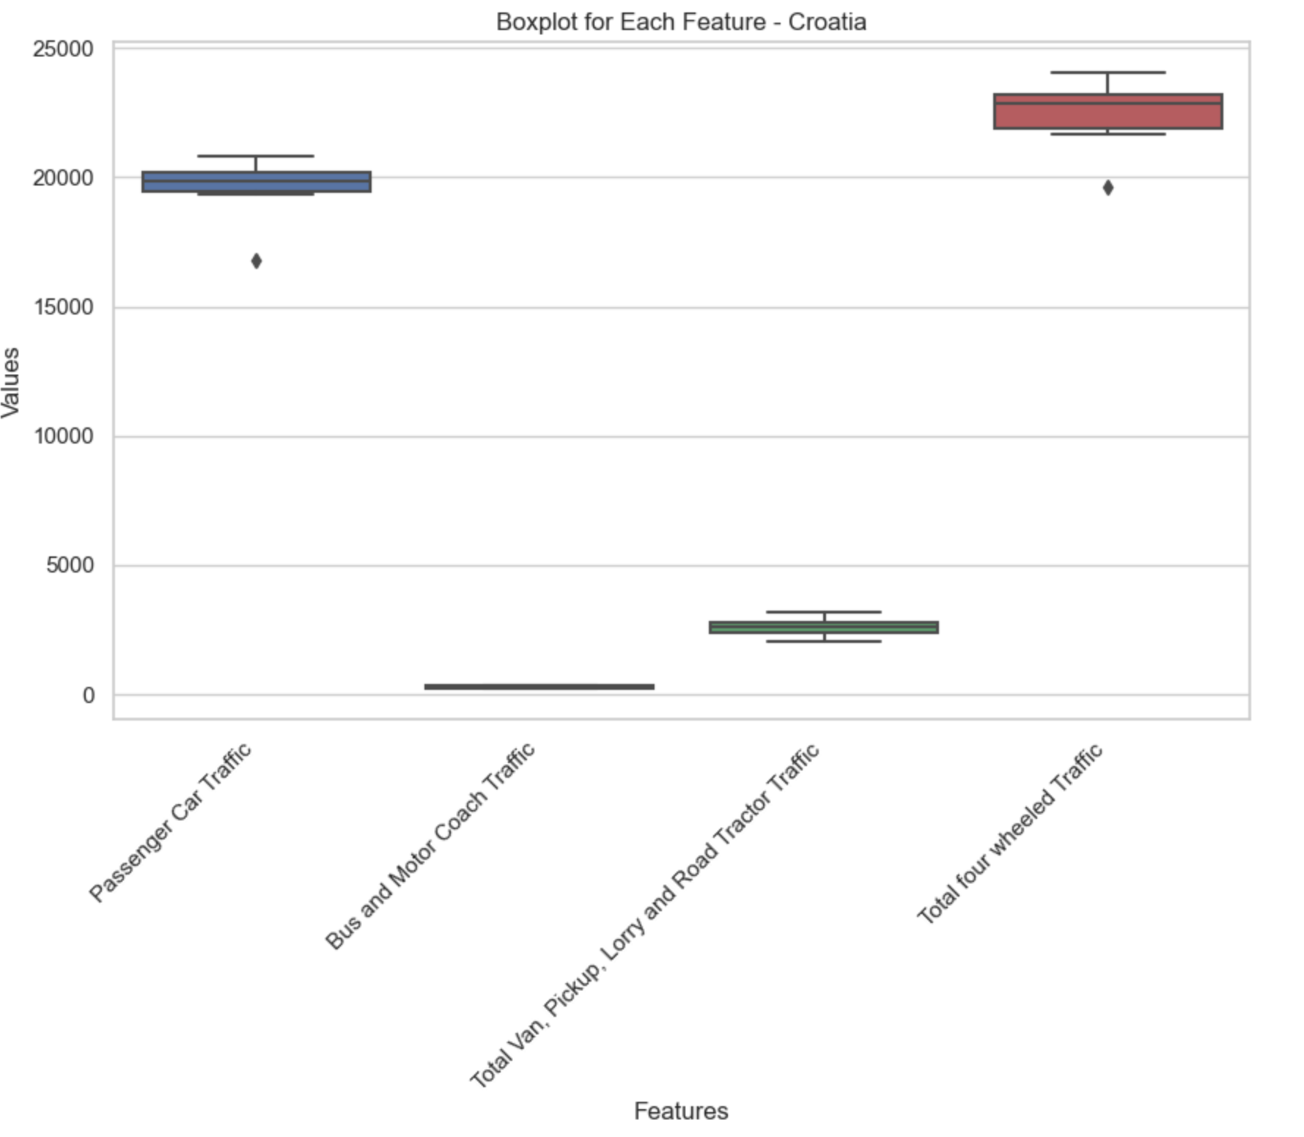

1. *Boxplot for each feature in Croatia over time*

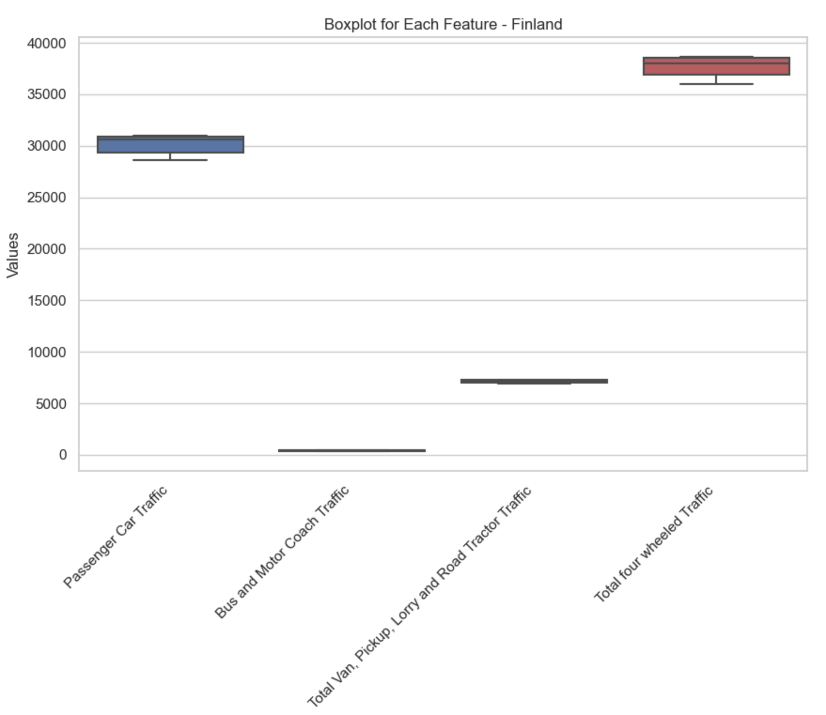

1. *Boxplot for each feature in Finland over time*

## Data Preparation & Visualisation – Preparation for Statistics and ML

After EDA, we decide to take following actions:

* Work on percentages.
* Filling missing data.
* Scaling the data.
* Handle outliers.

If we look at data for Austria and Belarus in 2021, we can clearly see that the total traffic metric is about 50 times bigger in Austria. This might be because:

* Population size is different.
* In one of the countries traffic data is not well represented with respect to the total population.
* The development of a country may influence its vehicle traffic.

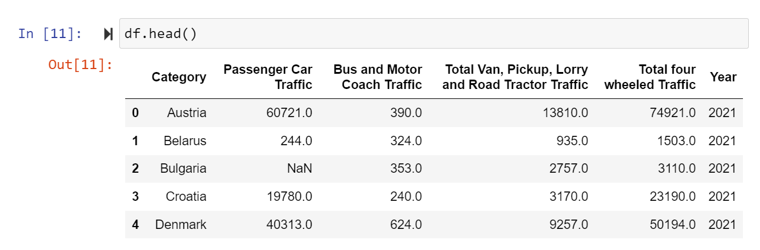

1. *Dataset head*

To solve previous problem, we now convert traffic metrics as percentages with respect to the total traffic.

At first, we found 63 rows where there is a mismatch in the metric sum:

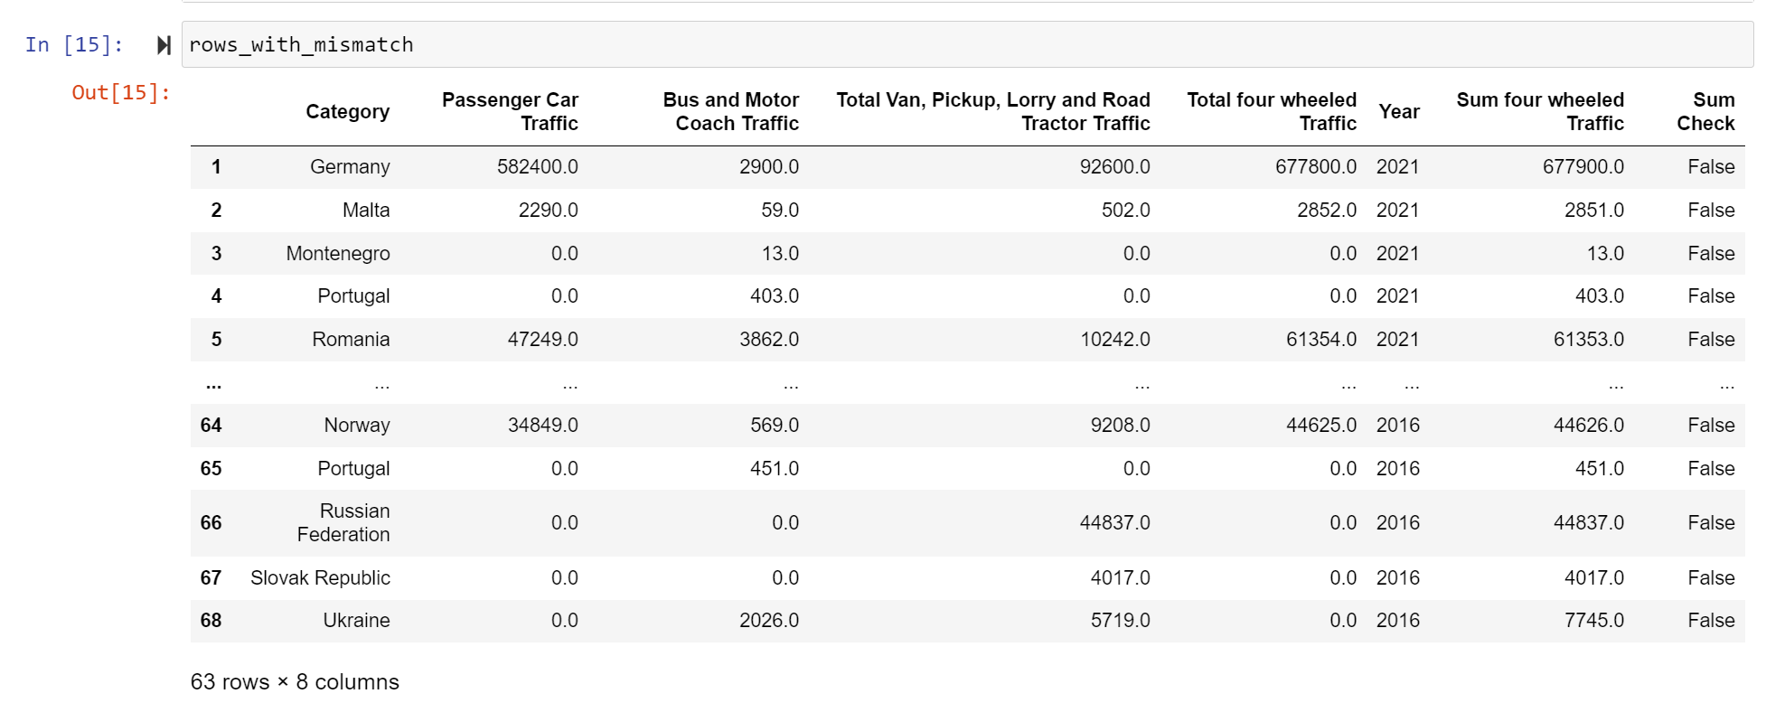

1. *Dataset rows with total sum mismatch*

As sum numbers might be rounded, all samples where the difference between the already available sum and the calculated one is greater than 1% were removed:

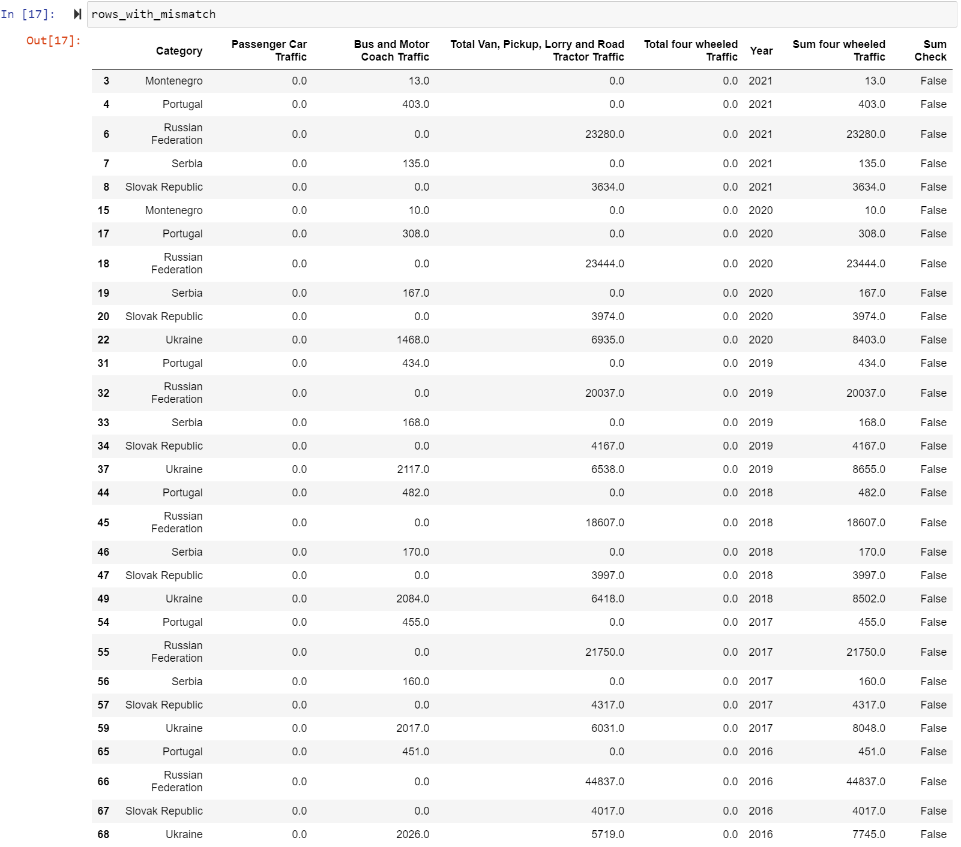

1. *Dataset rows with total sum mismatch considering 1% margin*

This action reduced rows to 152. Also, Bulgaria was dropped as it was the only showing NaN values:

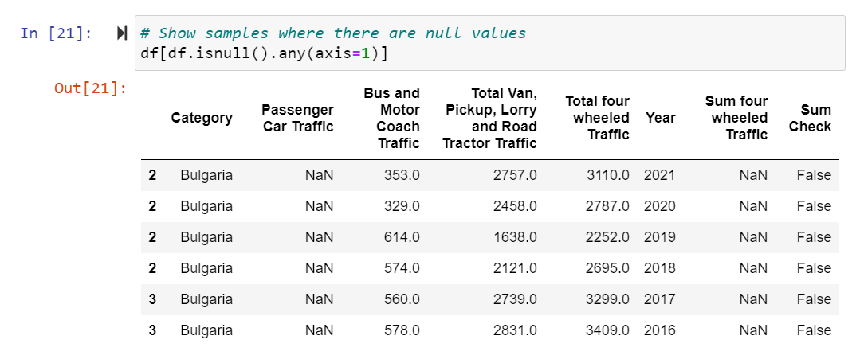

1. *Dataset rows with NaN values*

Now, we could finally build the percentage metrics:

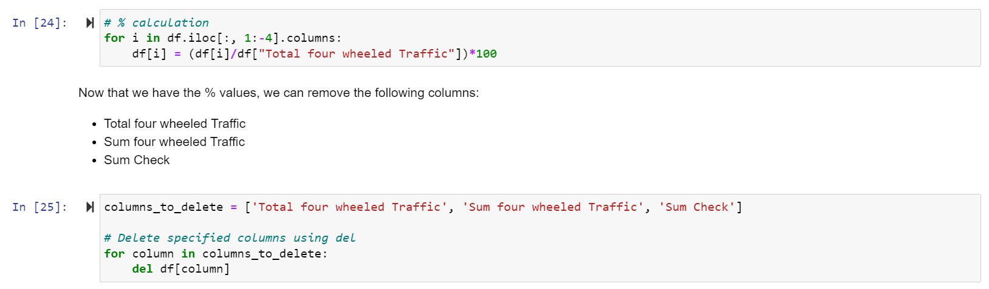

1. *Building of percentage metrics*

When countries had missing metrics for specific years, the mean of available traffic data was used.

*Filling missing values with the mean or median is a practical and widely-used approach in data preprocessing. It provides a simple solution to handle missing data while preserving the integrity of the dataset. (Firdose T., 2023)*

As a result of those tasks, we can now plot again the “metric by year over categories” bar chart to confirm that missing values and unbalance are not problems anymore:

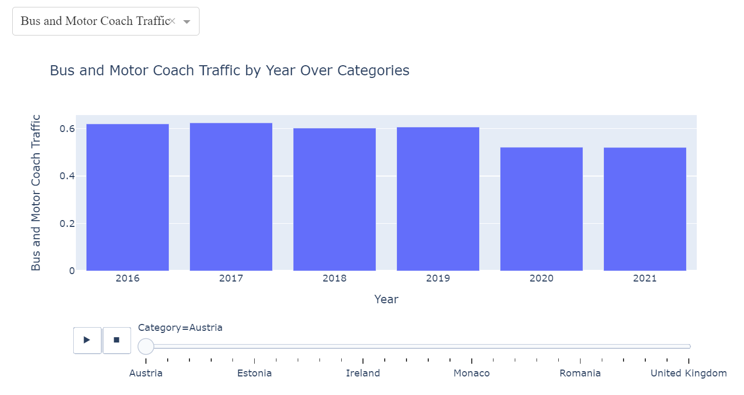

1. *Bus and motor coach traffic by year for Austria*

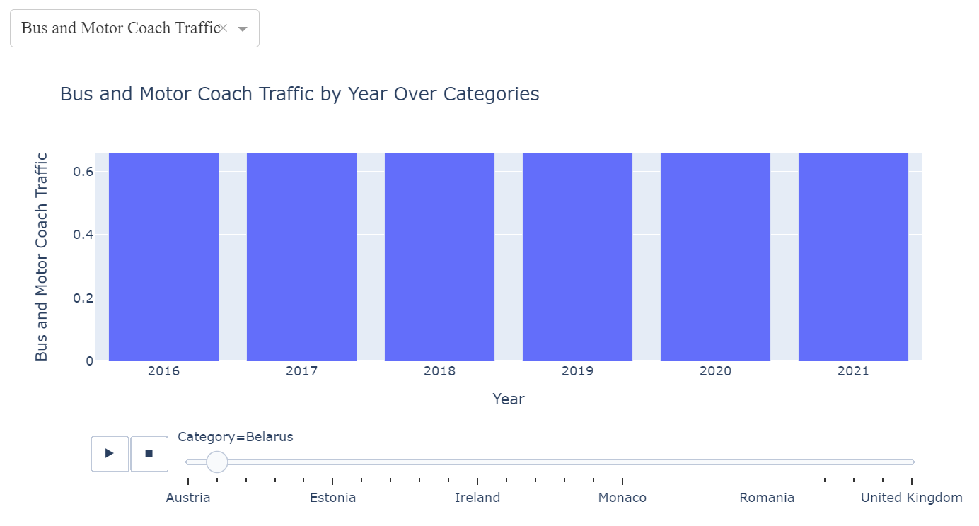

1. *Bus and motor coach traffic by year for Belarus*

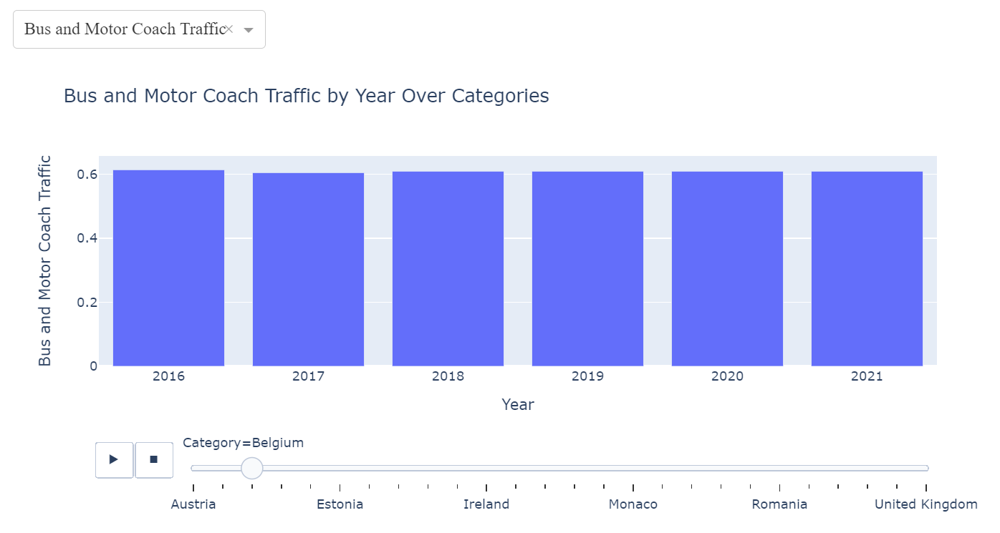

1. *Bus and motor coach traffic by year for Belgium*

As the data is between 0 and 100 (given that we are talking about percentages), dataset was scaled using MinMaxScales to have values ranging from 0 to 1:

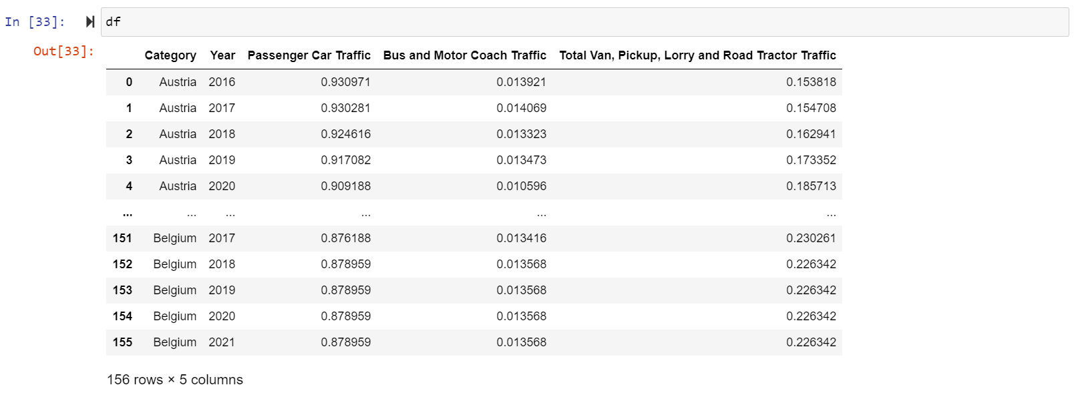

1. *Quick dataframe check after MinMaxScales*

*MinMaxScales scales and translates each feature individually such that it is in the given range on the training set, usually between zero and one. (scikit-learn, 2019)*

This drastically improved the outlier’s problem with the following results:

* Croatia, Ireland, North Macedonia, and Slovenia had outliers removed.
* Latvia and Spain had outliers reduced.
* Portugal, Russian Federation, Serbia, and Slovak Republic, which presented evident outliers, were removed due to the cleaning process.

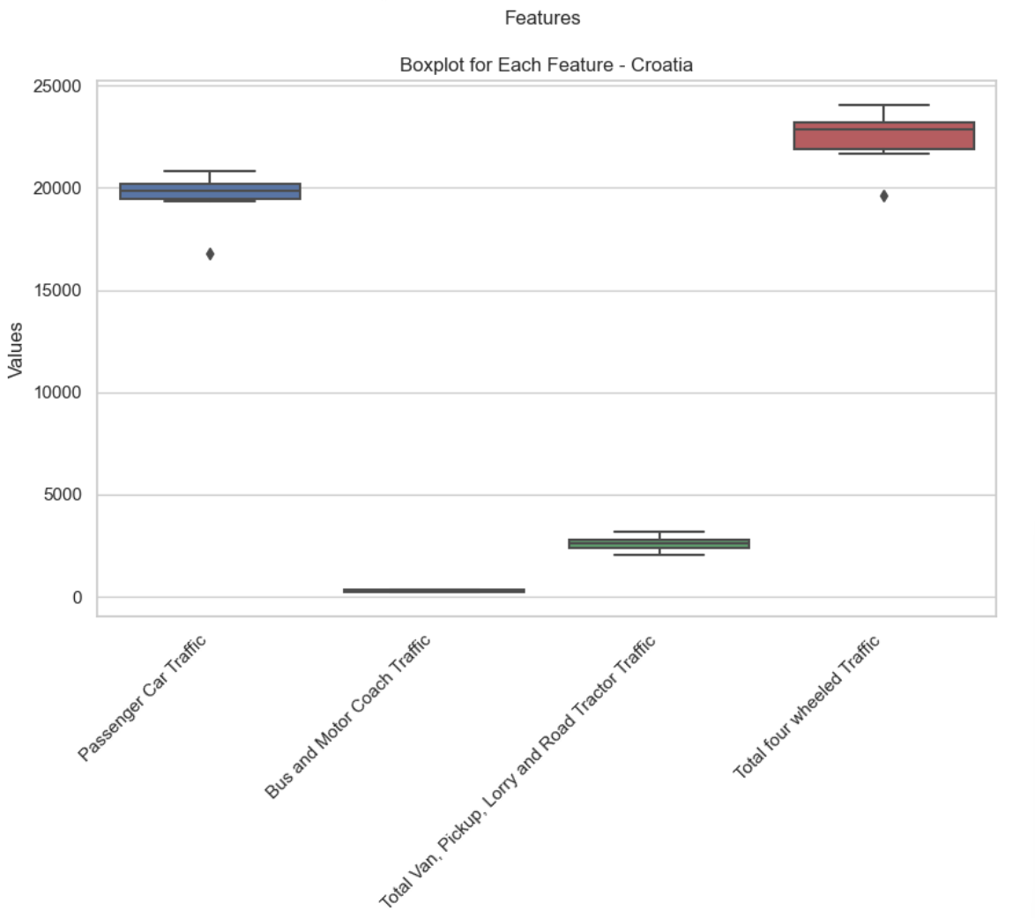 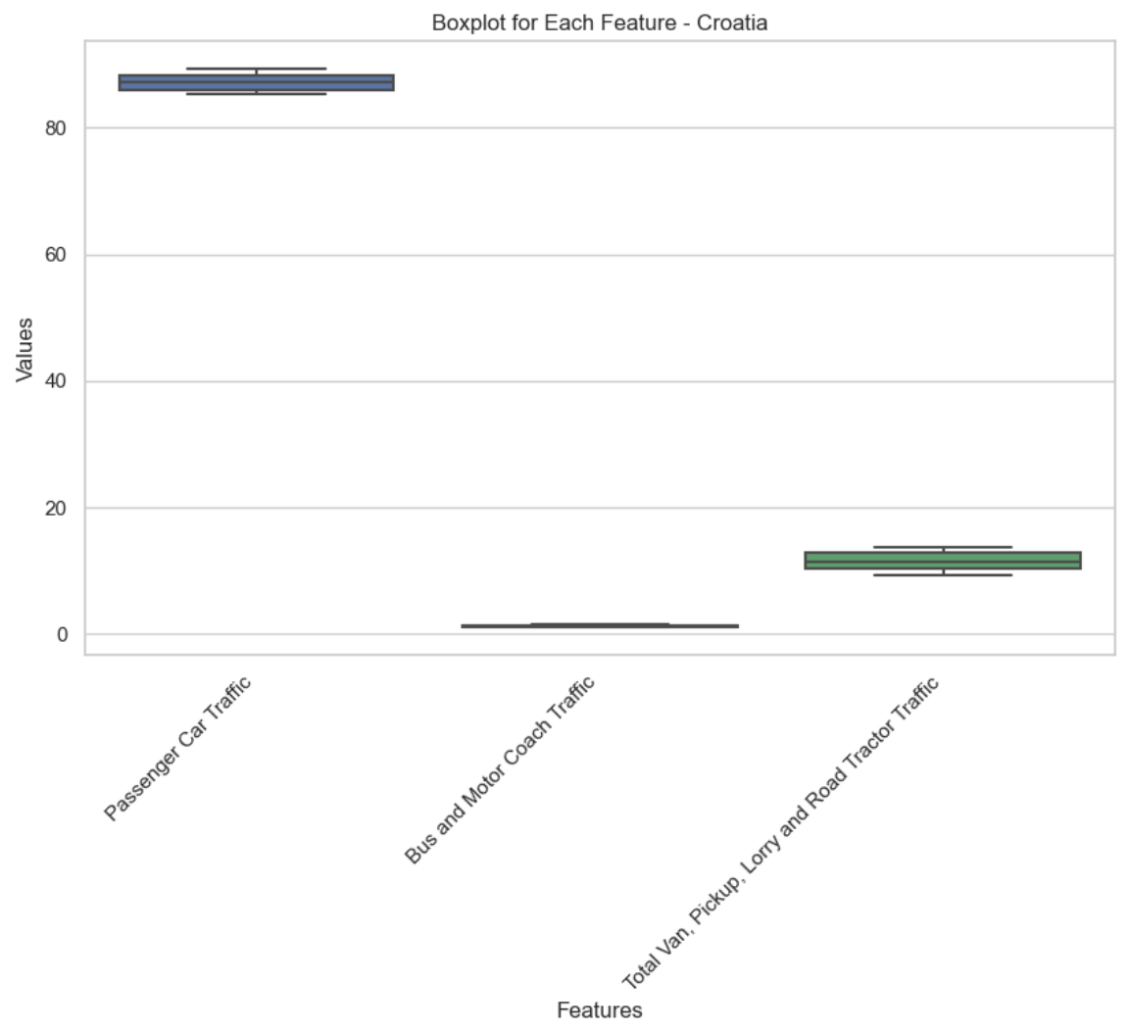

1. *Boxplot comparison for Croatia to show how scaling impacted outliers*

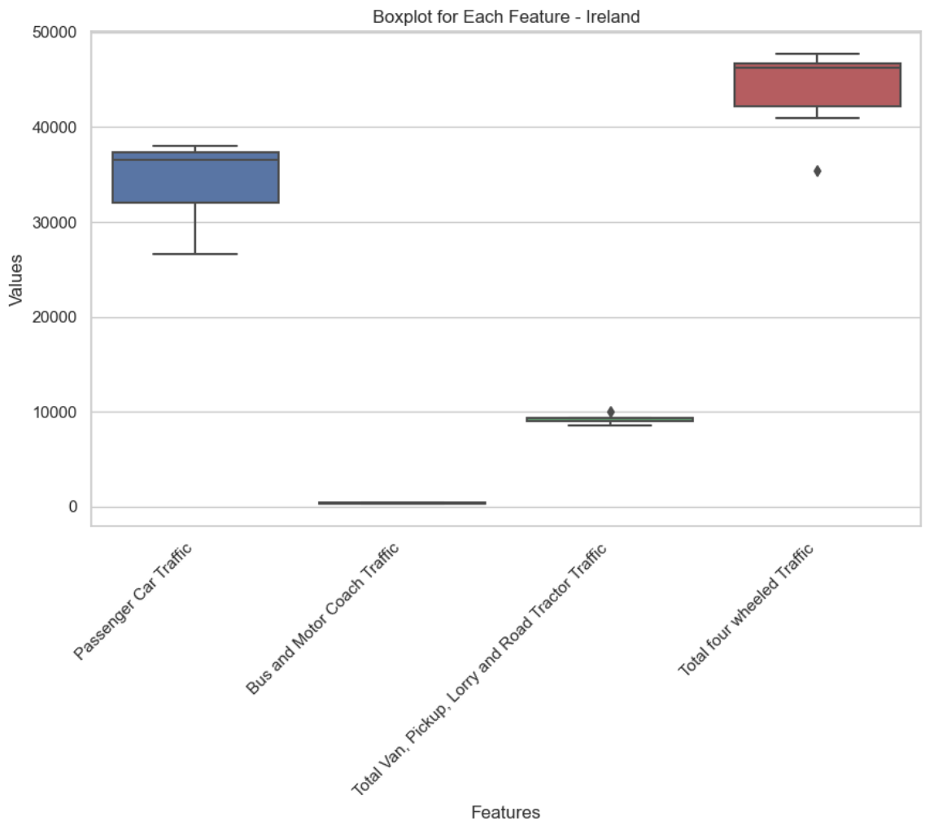 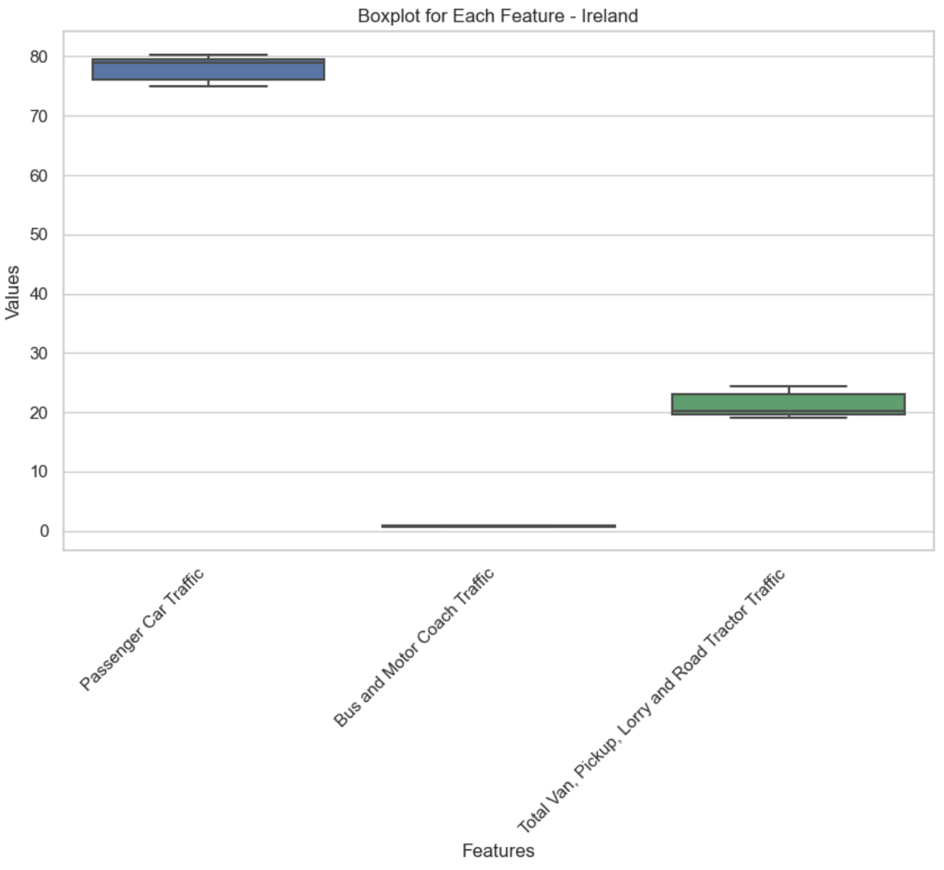

1. *Boxplot comparison for Ireland to see how scaling impacted outliers*

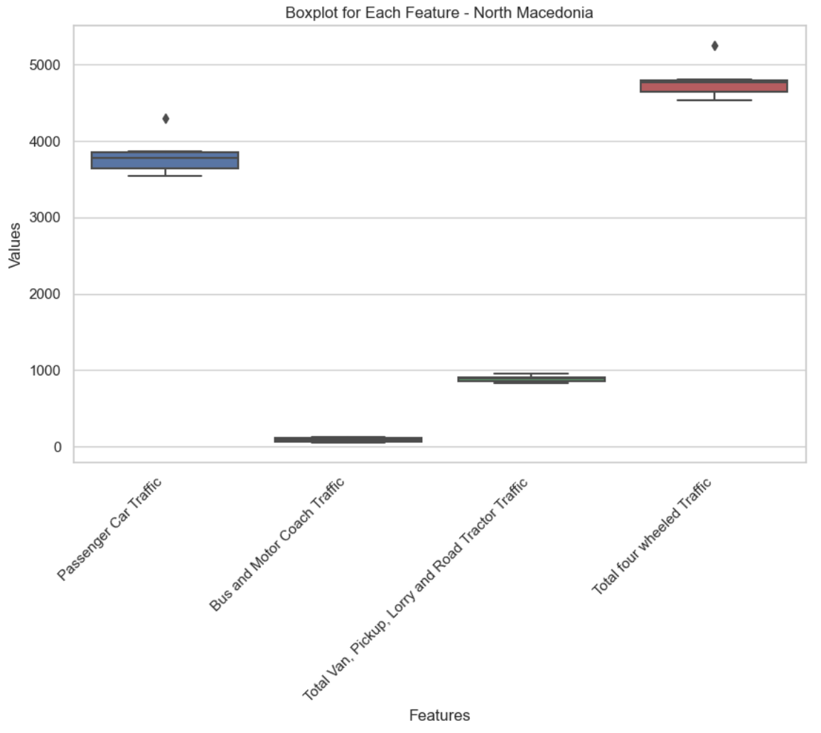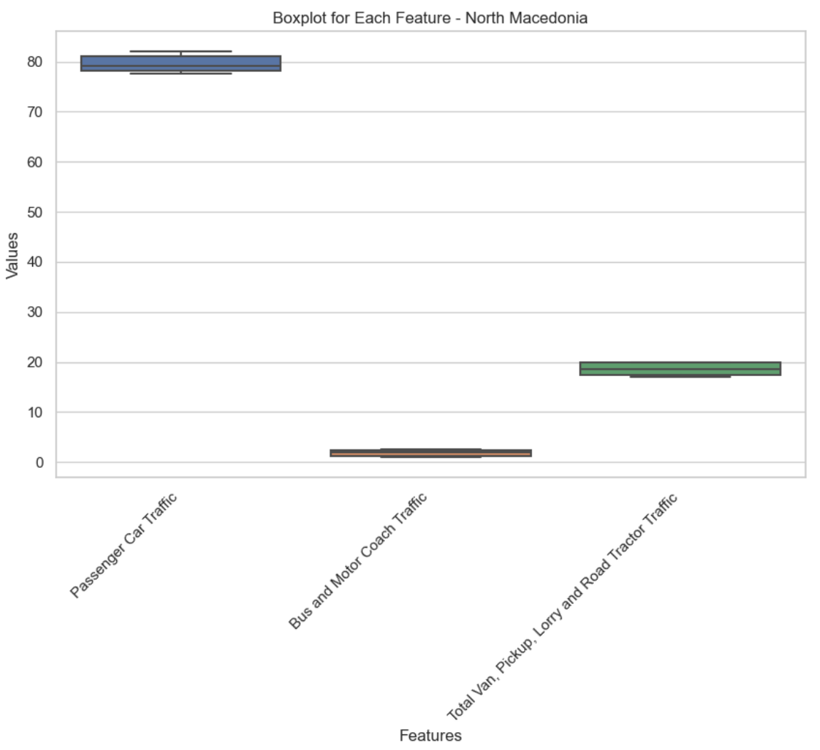

1. *Boxplot comparison for North Macedonia to see how scaling impacted outliers*

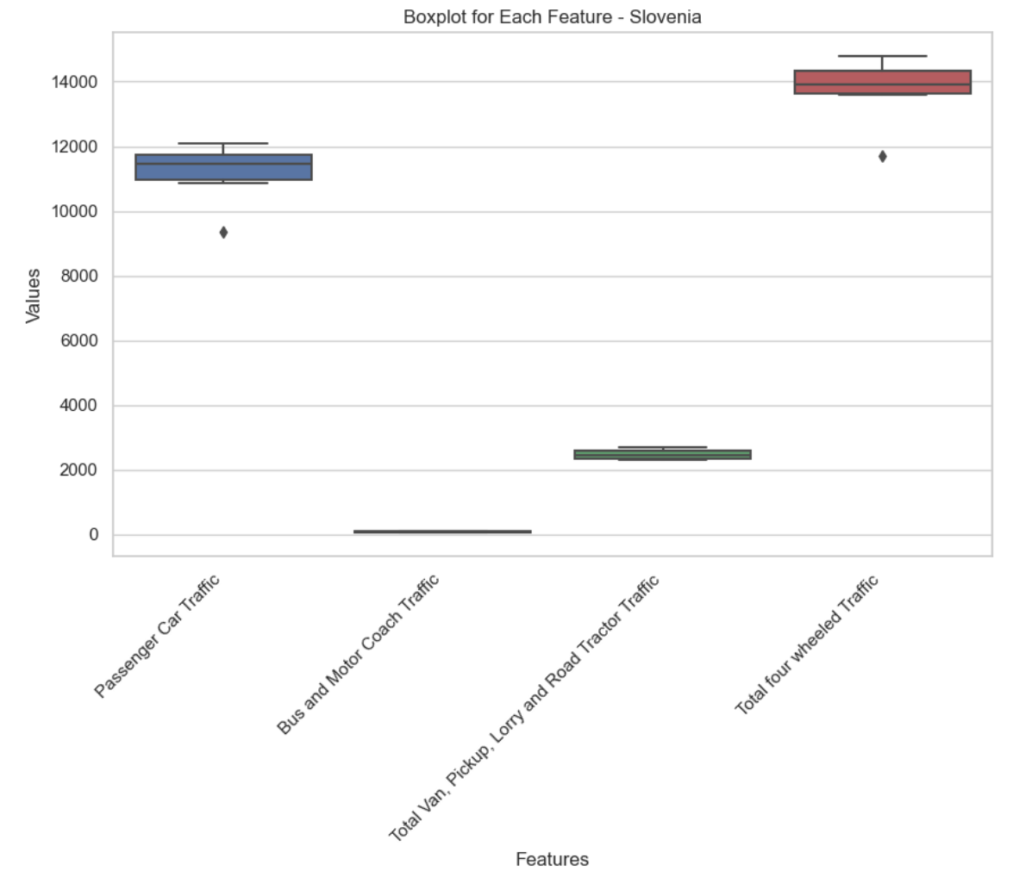 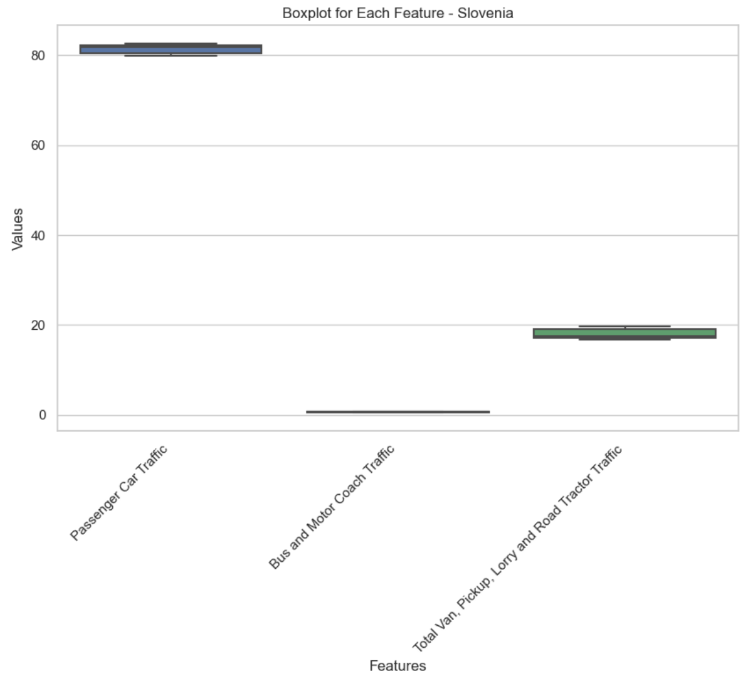

1. *Boxplot comparison for Slovenia to see how scaling impacted outliers*

## Statistics – Descriptive statistics

As we want to initially focus on Ireland, first thing we want to do is visualize its traffic trends by vehicle type over time:

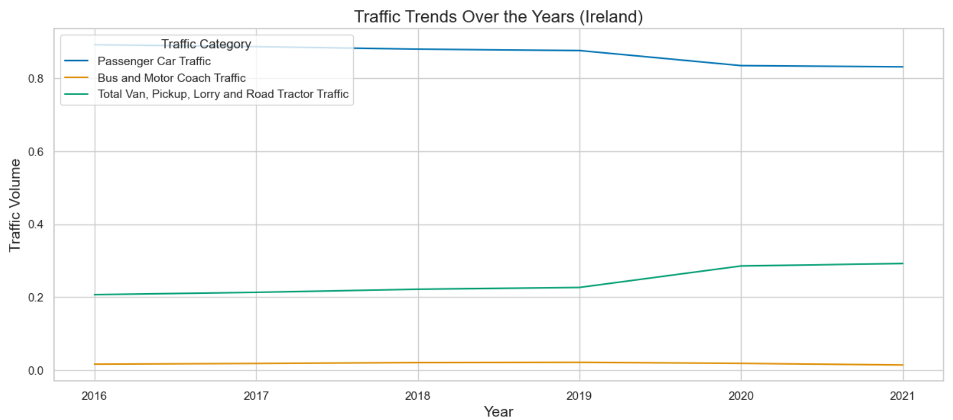

1. *Ireland traffic trend over time*

Let’s also look at the quartiles of Ireland metrics:

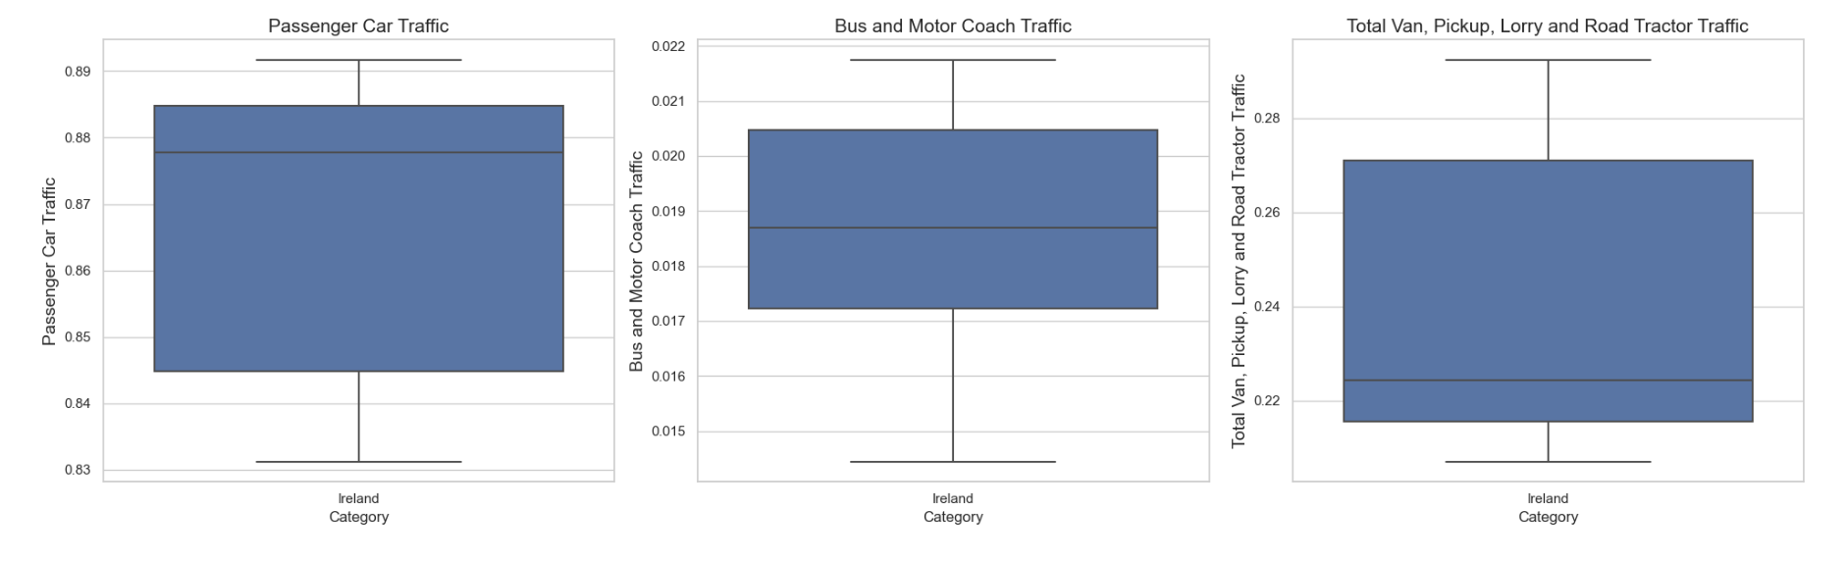

1. *Ireland traffic metrics boxplots*

*In a boxplot, the median is represented by the line that divides the box into two parts. This line marks the midpoint of the data. Half of the scores are greater than or equal to this value, and half are less. It’s also known as the second quartile. (Mcleod S., 2019)*

Looking at median lines we can say that passenger cars constitute most of the traffic in Ireland, evidenced by a prominent line with significant year-to-year variation; bus and motor coach traffic is comparatively lower with less variability, while the last traffic metric has the lowest median among the three categories.

This can also be confirmed computing Mean, Median, Mode and Standard deviation for those metrics, showing the following results:

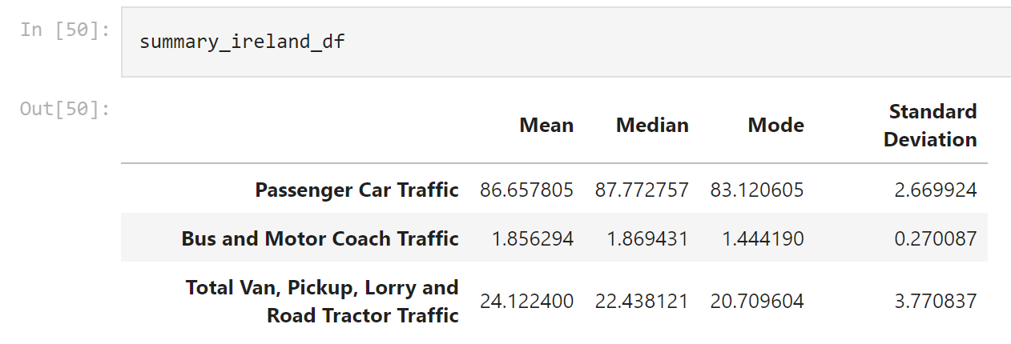

1. *Mean, Median, Mode and Standard deviation for Ireland*

This is a clear statement about the fact that in Ireland people tend more to travel with their own cars instead of using public transportation.

Let's see same results for Europe:

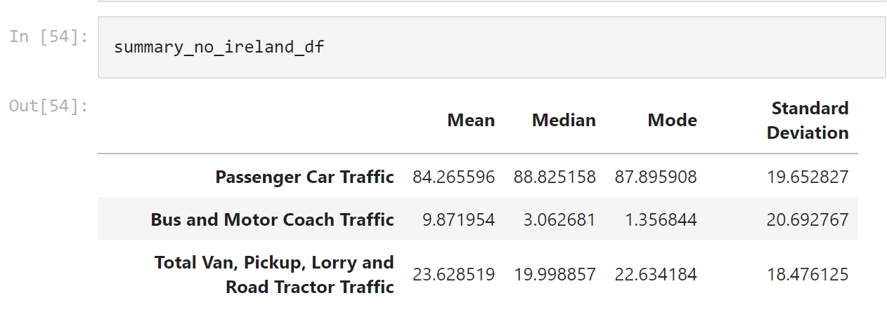

1. *Mean, Median, Mode and Standard deviation for EU excluding Ireland*

From the data extracted, we can observe:

* The mean value for passenger car traffic in Ireland is higher than the mean for Europe, but with a median slightly lower than the European one. This suggests that Ireland has a higher reliance on passenger cars compared to the average European country, but not the highest.
* The mean and median values for bus and motor coach traffic in Ireland are significantly lower than in Europe. This could suggest a lower reliance on public transportation in Ireland. The standard deviation is also much lower in Ireland, indicating less variability in bus and motor coach traffic.

Possible causes for these differences could be related to the geographical, economic, and infrastructural characteristics of Ireland. For example, Ireland’s smaller size and population density could lead to a higher reliance on personal vehicles (passenger cars) and less on public transportation (buses and motor coaches).

## Statistics – Inferential statistics

We now want to identify confidence intervals for Ireland traffic metrics. Let's start with our favourite metric "Bus and Motor Coach Traffic":

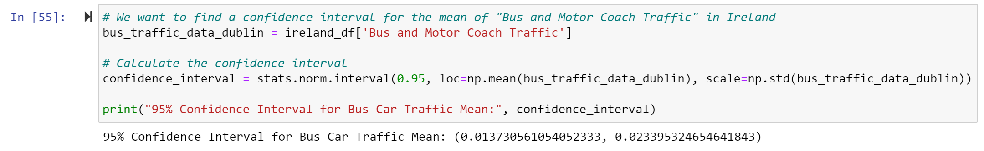

1. *Bus and Motor Coach Traffic confidence interval in Ireland*

*A confidence interval in statistics is a range of values that is likely to contain a population parameter with a certain level of confidence. (Bevans R., 2020).*

Previous results show that we can be 95% confident that if we enlarge our population - true population - (for example looking at data for 2022, 2023 and even future years such as 2024), the bus and motor coach traffic percentage would be between 1.37% and 2.34%.

*The t-test tells you how significant the differences between group means are. It lets you know if those differences in means could have happened by chance. (Bevans, R., 2020).*

If we apply a t-test to understand if there is any chance of having the bus and motor coach traffic mean equal to 5%, we get an extremely small p-value:

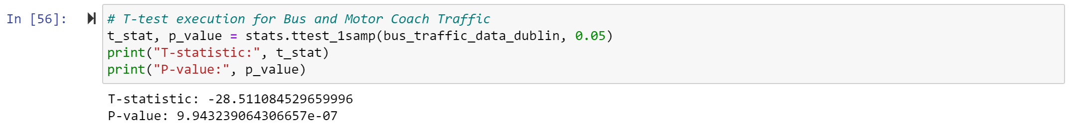

1. *T-test for bus and motor coach traffic mean equal to 5% in Ireland*

This indicates that the mean of "Bus and Motor Coach Traffic" in Dublin is significantly different from 5%. Results would have been different considering a % value falling within or close to the confidence interval.

Confidence intervals were also computed for other metrics:

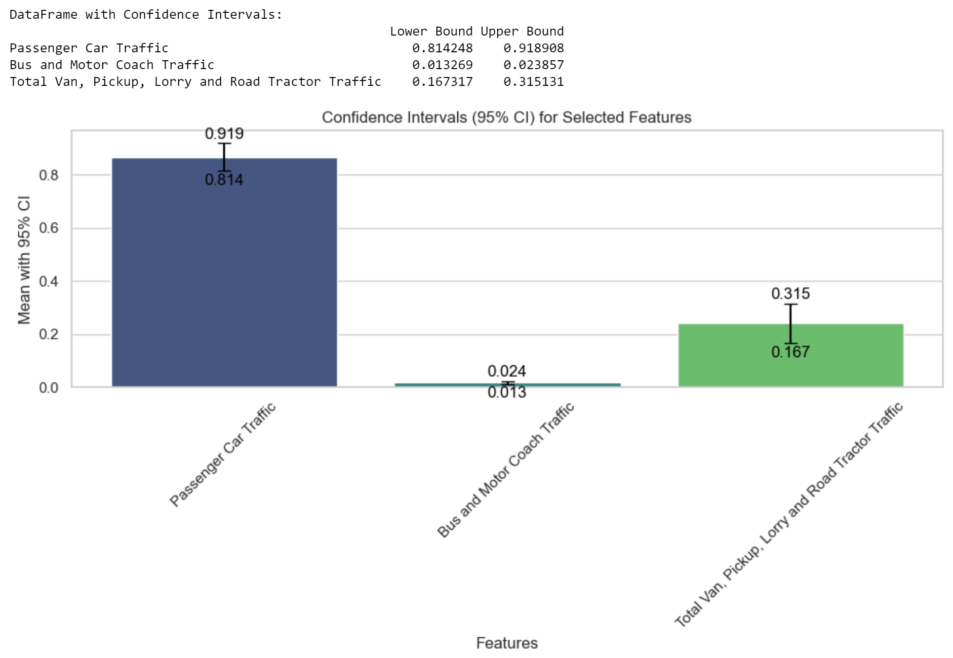

1. *Traffic metrics confidence intervals in Ireland*

The width of the confidence interval reflects the precision of the estimate. A narrower interval means that the estimate is more precise, while a wider interval means that the estimate is less precise.

This means that the estimate for passenger car traffic is less precise than the estimate for bus and motor coach traffic.

## Statistics – Parametric and non-parametric inferential statistical

To better understand how Ireland compares to other EU countries, parametric and non-parametric inferential statistics techniques were used.

Before proceeding with parametric inferential statistical techniques, following assumptions had to be verified:

* The populations are independent. In other words, their outcomes do not affect each other.
* The populations have a normal distribution.
* The variances of the normal distributions are equal.

***Parametric inferential statistical techniques - Assumptions***

For each time-series, independence was verified using the Ljung-Box test. We were lucky enough to confirm that all time-series are independent:

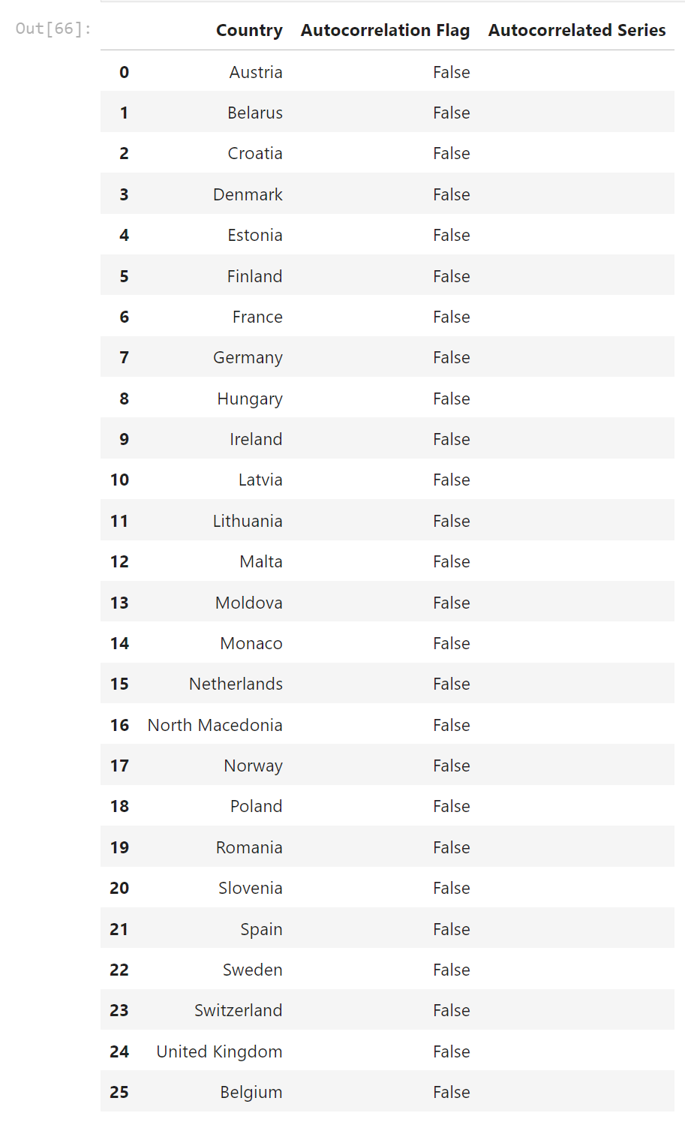

1. *Ljung-Box test results*

*The Ljung-Box test, named after statisticians Greta M. Ljung and George E.P. Box, is a statistical test that checks if autocorrelation exists in a time series. (Zach, 2020)*

To confirm that those time-series are also normally distributed, Shapiro-Wilk test was used:

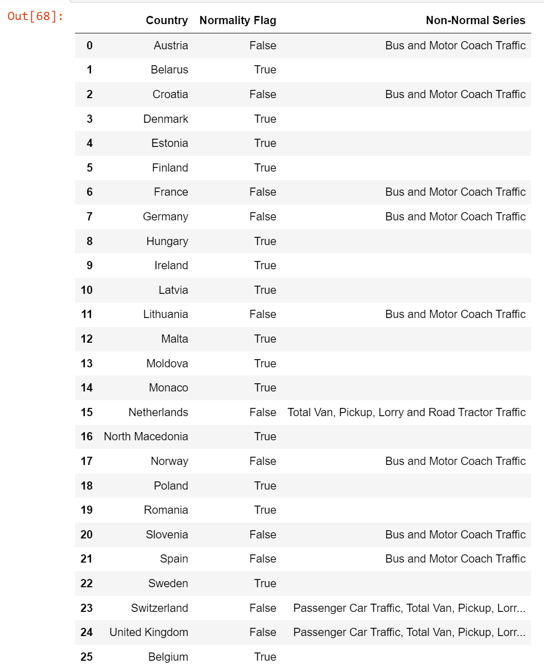

1. *Shapiro-Wilk test results*

*The Shapiro-Wilk test is a hypothesis test that is applied to a sample and whose null hypothesis is that the sample has been generated from a normal distribution. (Malato G., 2023)*

This, together with the variance test, left us only with the following countries to be considered for parametric inferential statistical techniques:

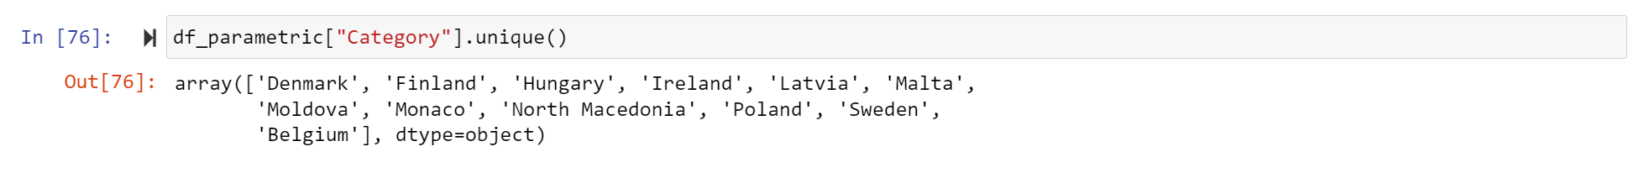

1. *Combination of Ljung-Box, Shapiro-Wilk and Variance tests*

*A variance test is a statistical method used to determine whether the variances of two or more samples are equal. (Statistics LibreTexts, 2016)*

***Parametric inferential statistical techniques - T-Test***

After using T-Test to compare Bus and Motor Coach Traffic between Ireland and Denmark, rejecting the null hypothesis that the mean of the "Bus and Motor Coach Traffic" in Ireland is equal to the mean of the same variable in Denmark, we did the same for all countries:

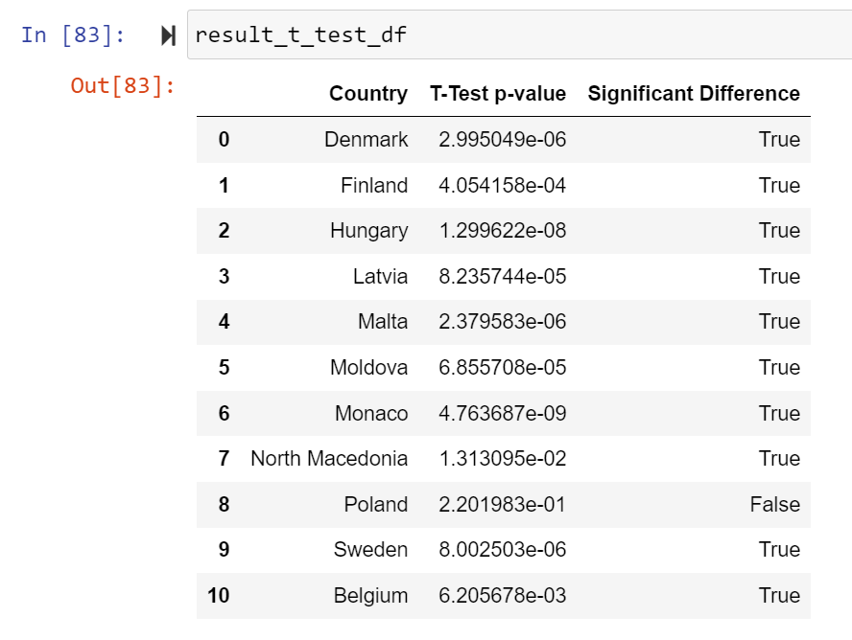

1. *T-test on bus and motor coach traffic between Ireland and other countries*

Interestingly we can learn that the only country, from the ones available, where the mean percentage of "Bus and Motor Coach Traffic" is like Ireland is Poland.

***Parametric inferential statistical techniques - One-Way Anova***

*A One-Way ANOVA (Analysis of Variance) is a statistical test used to analyze the difference between the means of more than two groups. It uses one independent variable. (Bevans R., 2020)*

To confirm results got from T-Test, One-Way Anova was also applied with the following hypothesis:

* H0 -> The mean "Bus and Motor Coach Traffic" is equal across all categories (countries).
* H1 -> At least one mean "Bus and Motor Coach Traffic" is significantly different from the others.

This means that there is enough evidence to suggest that the mean "Bus and Motor Coach Traffic" is significantly different across at least two categories (countries). In fact, from T-Test, we found that the only similarity is with Poland.

***Parametric inferential statistical techniques - Two-Way Anova***

*A Two-Way ANOVA (Analysis of Variance) is a statistical test used to analyze the difference between the means of more than two groups at multiple levels of two categorical variables. It uses two independent variables. (Bevans R., 2020)*

Now that we know that with inferential statistical techniques the only country like Ireland for the bus metric is Poland, we want to understand if the year in which this metric was recorded plays a role.

Thus, Two-Way ANOVA was used to find insights on time correlation. The finding is that the interaction between 'Category' and 'Year' does not have a significant effect on 'Passenger Car Traffic'.

***Non-parametric inferential statistical techniques - Kruskal-Wallis***

*The Kruskal-Wallis test is a non-parametric method used to determine whether there is a statistically significant difference between the medians of three or more independent groups. (Zach, 2019)*

As parametric techniques forced us to only consider a small portion of available data, we decided to focus on where we could find insights – specifically between Ireland and Poland.

Now that we don’t need to obey to assumptions for our time-series, we can look for correlation between Ireland and other countries for all metrics. Kruskal-Wallis test returned the following:

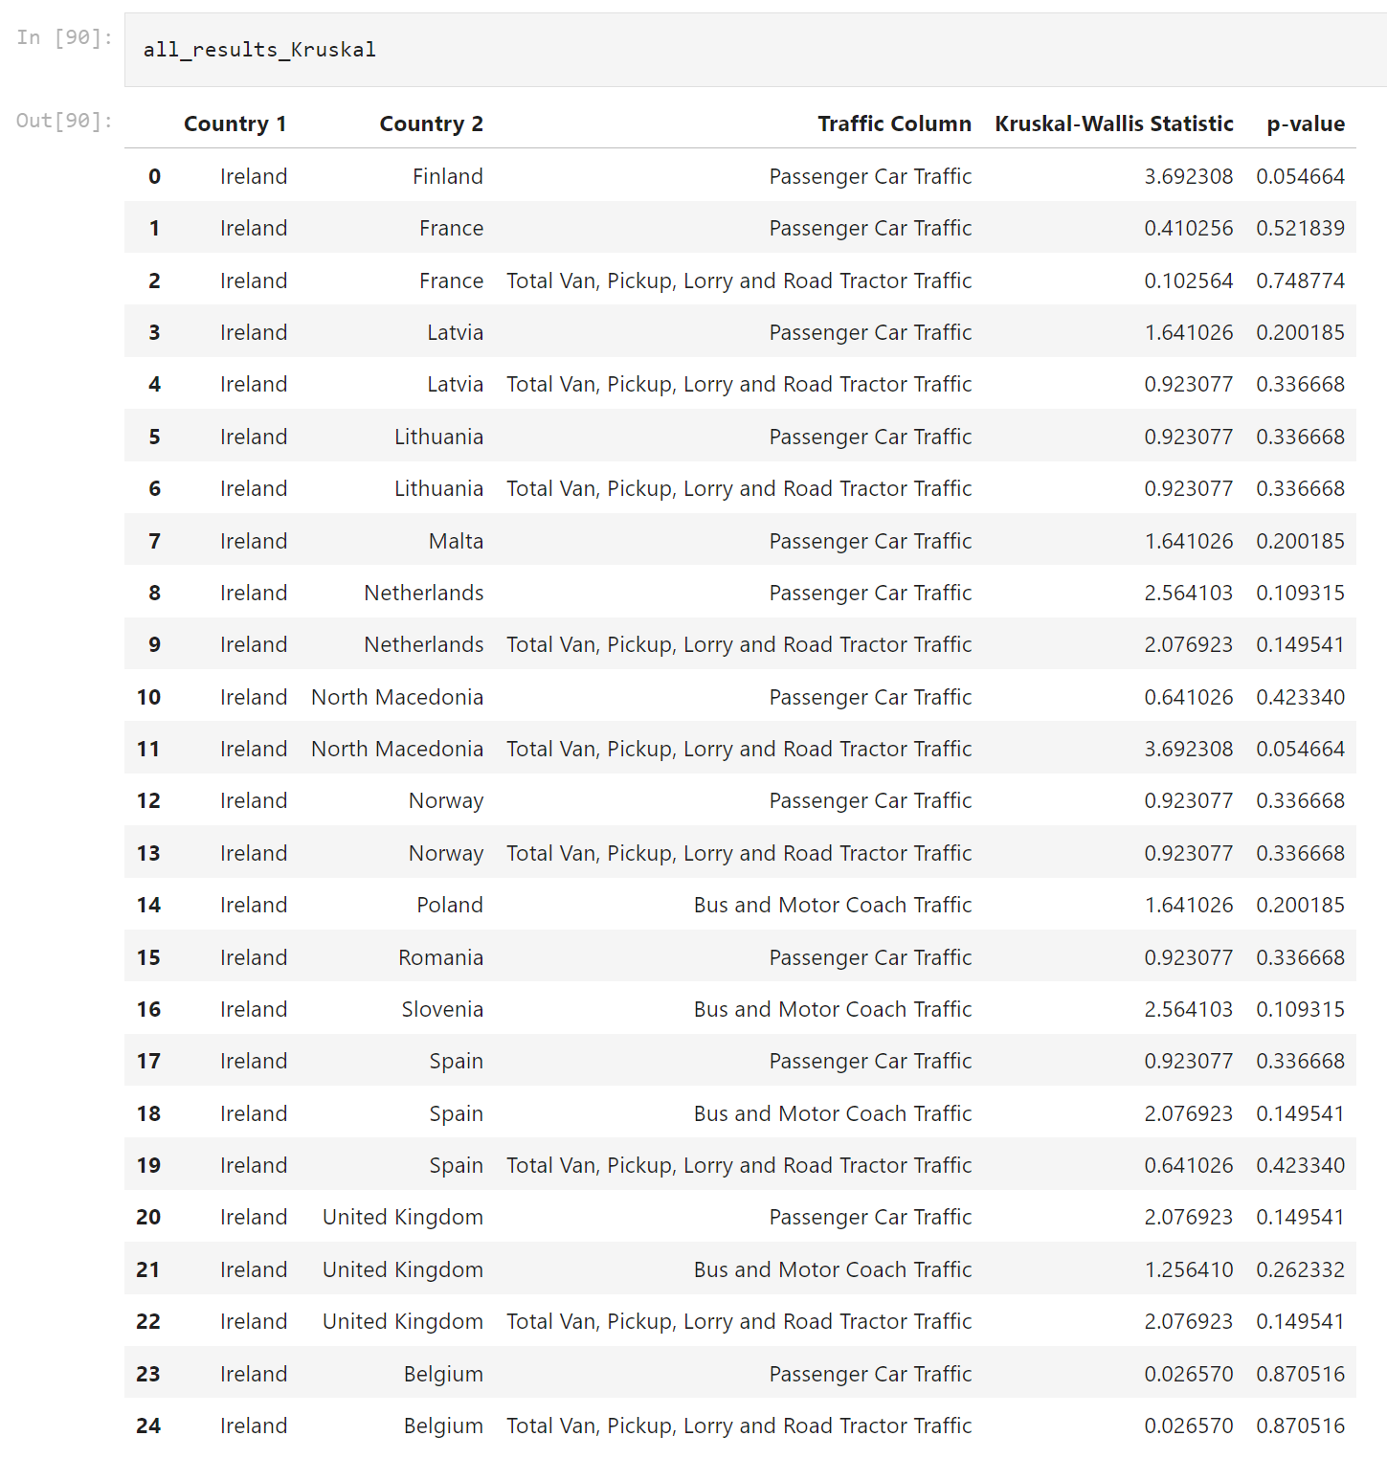

1. *Kruskal test results*

Now we can see that we do not only have the correlation with Poland, but we can extract many more insights such that between Ireland and Spain, for example, all metrics show a very similar mean.

***Non-parametric inferential statistical techniques – Wilcoxon***

*The Wilcoxon test, which can refer to either the rank sum test or the signed rank test version, is a nonparametric statistical test that compares two paired groups. The tests essentially calculate the difference between sets of pairs and analyze these differences to establish if they are statistically significantly different from one another. (Hayes A., 2019)*

Kruskal-Wallis results were also compared and checked against the ones obtained by Wilcoxon:

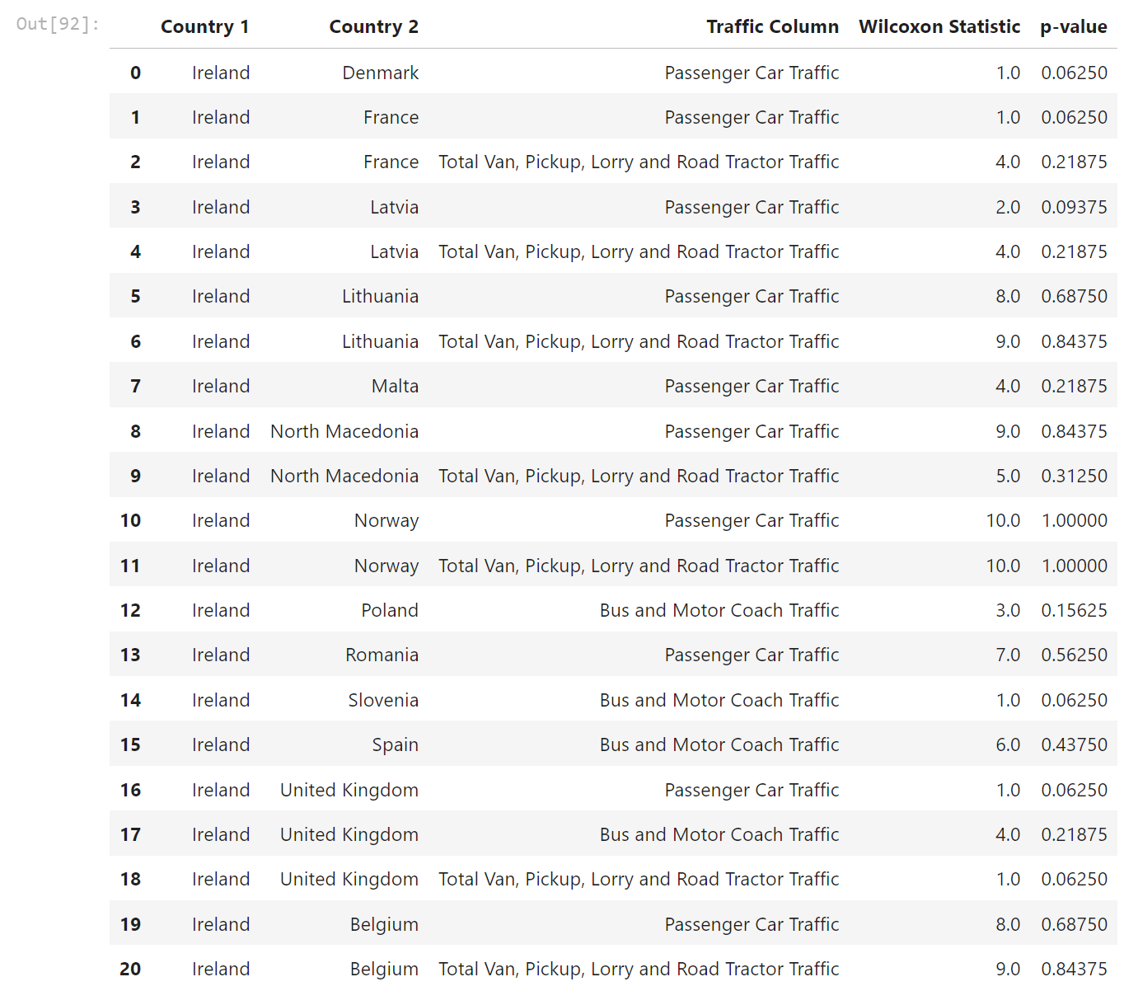

1. *Wilcoxon test results*

Interestingly, in this case, the metric similarities found between Ireland and Spain do not apply anymore.

For this reason, we had taken for grant only similarities that would apply to both last two tests:

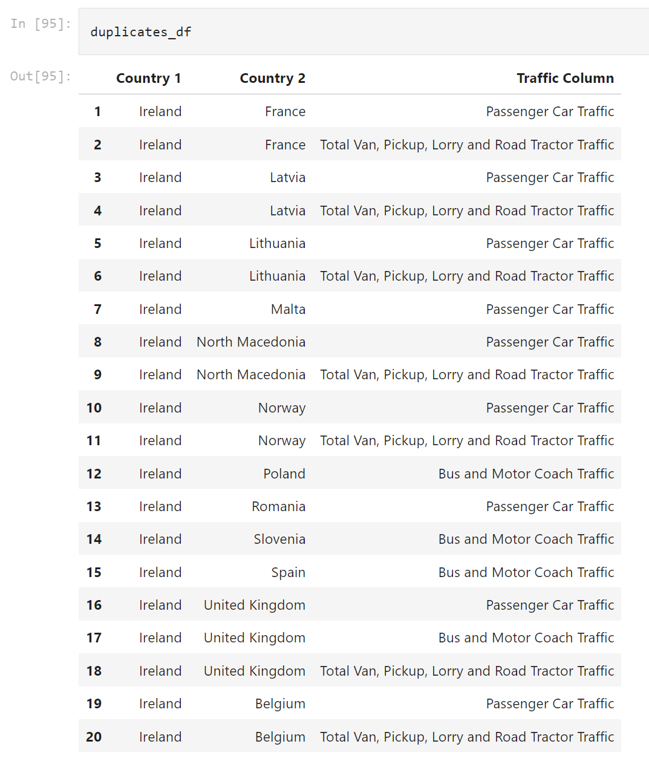

1. *Combination of Kruskal and Wilcoxon tests results*

From previous table we can try to extract some interesting insights.

At first, we see that Ireland is like 9 EU countries in terms of “Passenger Car Traffic”. This metric, according to our assumption, is the one that identifies the traffic generated by individuals not relying on public transportation for their mobility. It is very interesting that Ireland behaves similarly to countries different to each other such as Latvia, France, Spain, and Romania.

The only country where there is a full match is with United Kingdom, something I wasn’t surprised about given the similarity of the two countries (just to say one, they are both islands and infrastructure has quite probably evolved similarly).

## Machine Learning – Rationale and justification

After previous analysis, we understood quite well what countries exhibit similar behaviours in terms of percentage of traffic generated by four-wheeled vehicles.

We now want to advance our analysis and build a machine learning model as we don't only want to know how Ireland compares with other countries, but we also want to know how those countries will behave in the future years.

Given that traffic metrics in our dataset are time-series, we want to create a forecasting model to predict how those percentages will change in the future. This will give us an interesting overview of how four-wheel transportation would change in the following years for multiple countries.

To accomplish this, we use a supervised approach where our model learns from a portion of the dataset and then it’s tested on the remaining. Tested models were also trained after finding best hyper-parameters.

The simple and first model used is a Linear Regression model that is then compared and benchmarked with an LSTM.

To make things even more interesting, we wanted to relate traffic data to user reviews regarding public transportation usage. To do so, user reviews for capital cities of analysed countries were extracted with the following parameters:

* Content of the review
* Year of the review
* Score of the reviews

Whit this data, a sentiment analysis model was built to enhance our forecasting model.

The reason why we build a sentiment analysis model instead of using actual score from users is because we want to avoid bias that certain users would have on specific countries. In fact, we will train the sentiment model only based on text and score.

Once the sentiment model was available, it was used to inference sentiment score among all reviews. Review score means where then grouped by countries and years and used to extend the forecasting model.

## Machine Learning – Sentiment analysis

Given that looking for user review data among all available EU countries is quite complex, we decided to focus only to those that showed similar behaviours with Ireland.

User reviews were collected from TripAdvisor website and loaded in a single dataframe:

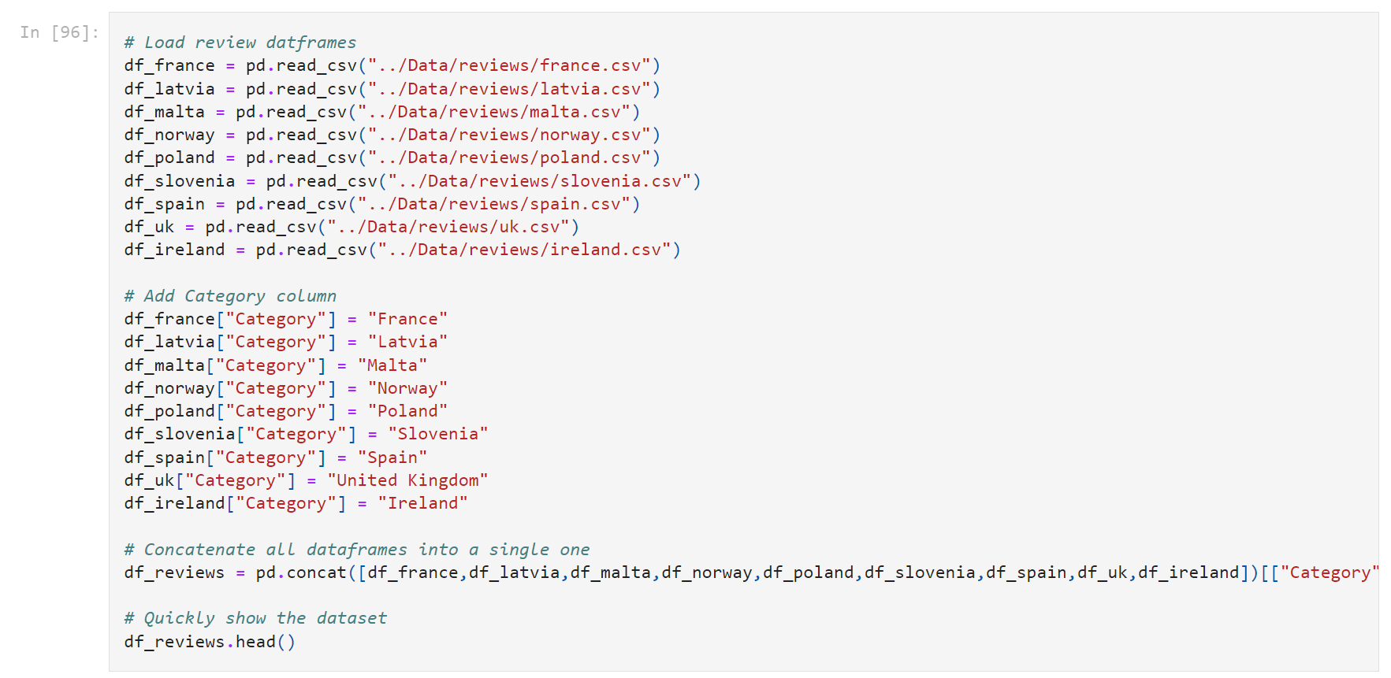

1. *Review dataset creation*

To enhance efficiency of text analysis, a set stemming tool was used to remove common English stop words and punctuation characters to reduce words to their root form. Below an example of processed reviews:

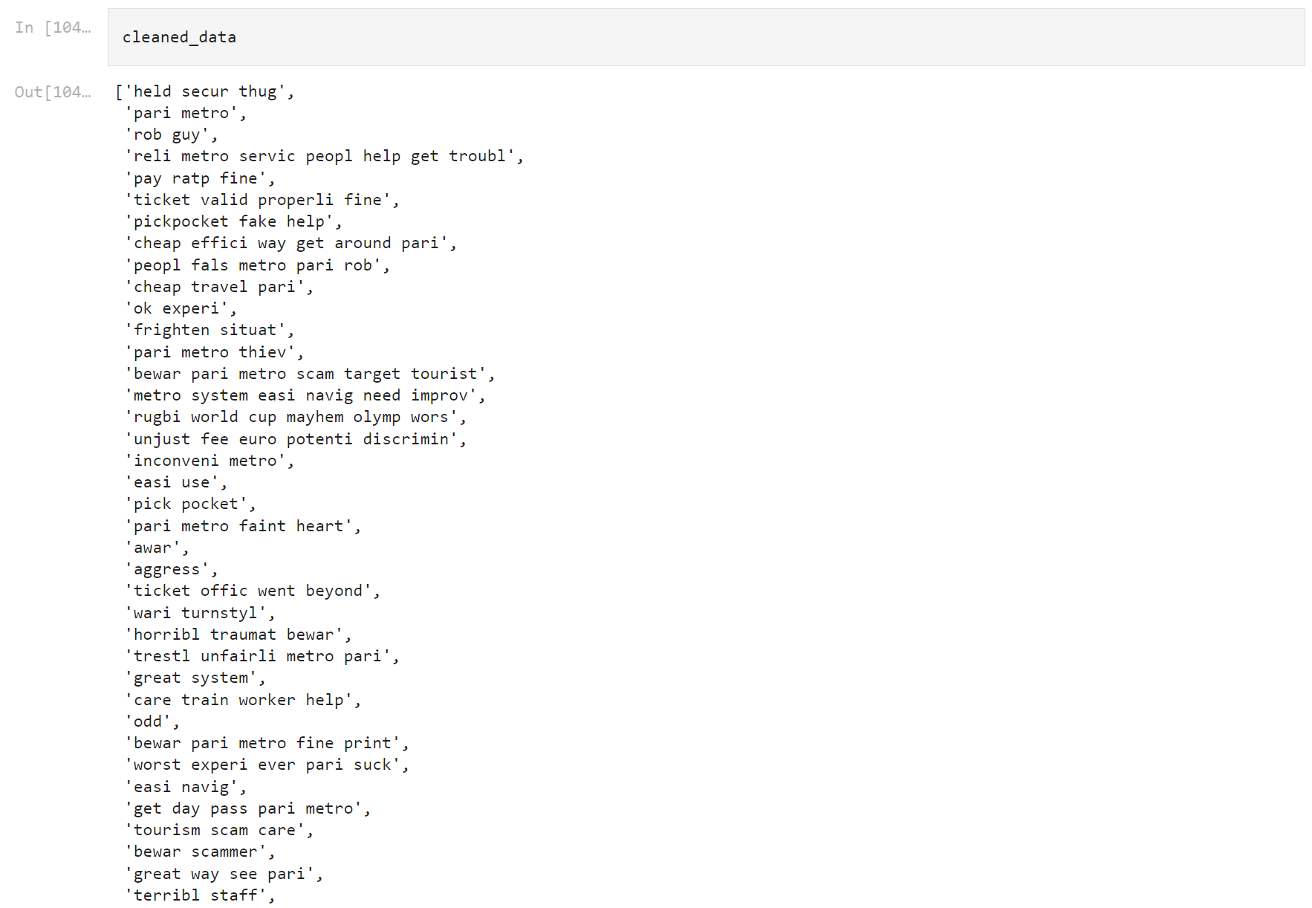

1. *Cleaned review data exploration*

To further preprocess the data and reduce its complexity, we decided to merge review scores 1-2 and 4-5. This is because we wanted to remove biases that could arise from user culture and try to extract review scores in an objective way.

This is the original score distribution:

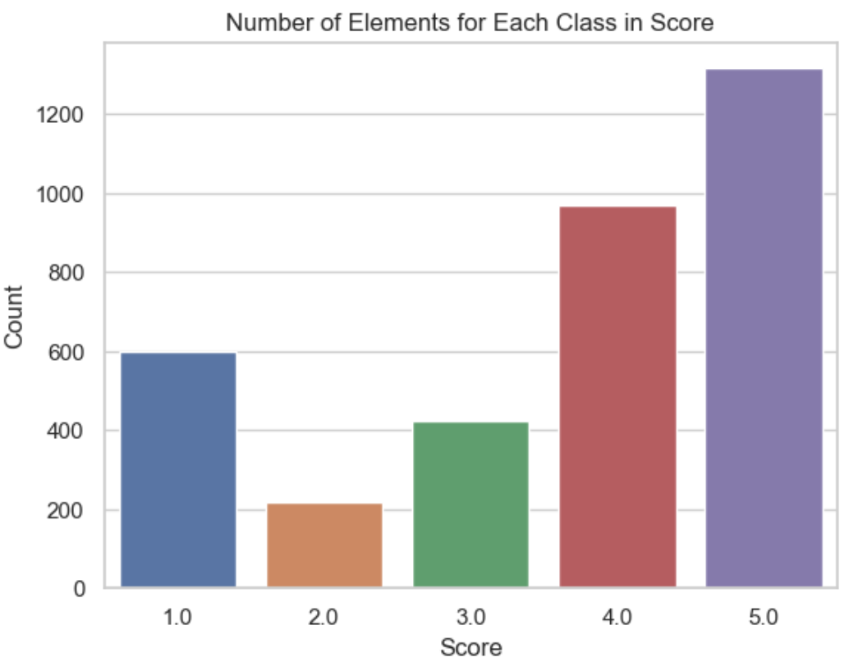

1. *Number of elements for each class in score*

And this is the updated after merging mentioned scores:

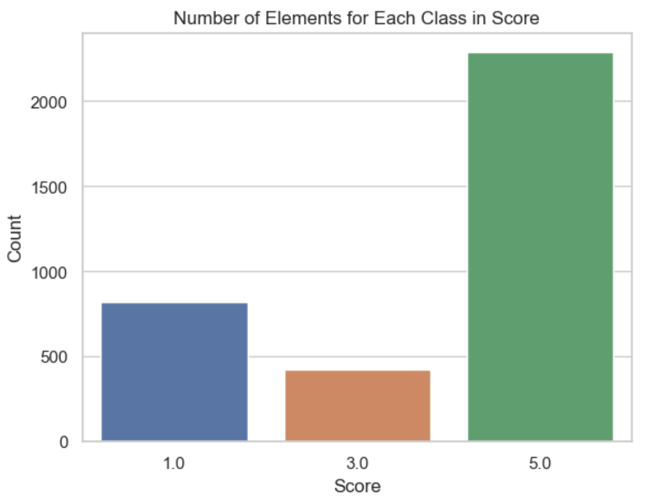

1. *Number of elements for each class in score after merging score groups*

As we don’t want our sentiment analysis model to be overfitting with a specific score (see score 5 where we have many more training data) we balanced the dataset using minority class sampling.

*Minority class sampling is a technique used in machine learning to handle imbalanced datasets. (Brownlee J., 2020)*

The following results were obtained:

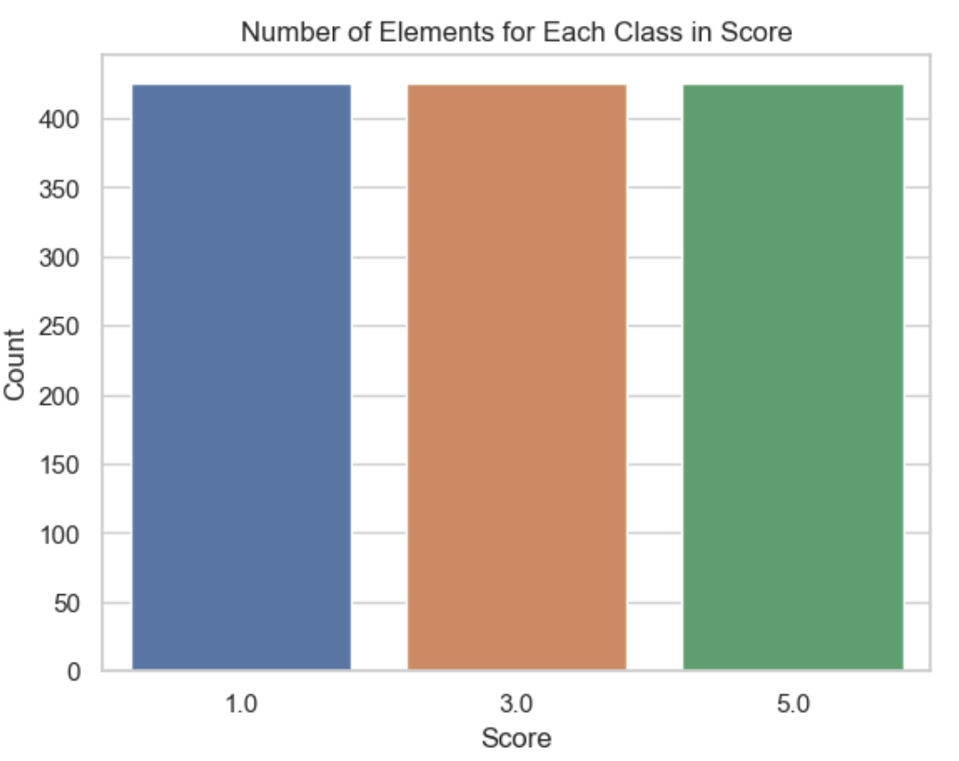

1. *Number of elements for each class in score after merging score groups and minority class sampling*

To be able to allow our model to understand text data, this has been converted into a numerical matrix of word counts thanks to a vectorization process.

Two techniques were used for this purpose: CountVectorzer and TfidfVectorizer.

From classification reports shared below we can see that, when reducing the number of classes, overall accuracy is increasing thanks to reducing score complexity and class sampling.

When looking at the reports obtained after the class sampling and for the two vectorization methods, we can say that:

* CountVectorzer shows a more balanced performance across classes, especially for Class 1 where Method 2 struggles with recall.
* TfidfVectorizer achieves perfect precision for Class 1 but at the cost of extremely low recall, indicating that it identifies very few instances of Class 1.

*CountVectorzer is used to convert a collection of text documents to a matrix of token counts. (Scikit-learn, 2018)*

*TfidfVectorizer is used to convert a collection of raw documents to a matrix of TF-IDF features. TF-IDF stands for Term Frequency-Inverse Document Frequency, a numerical statistic used to reflect how important a word is to a document in a corpus. (Scikit learn, 2018)*

Because of this, CountVectorzer is used as the preferred method.

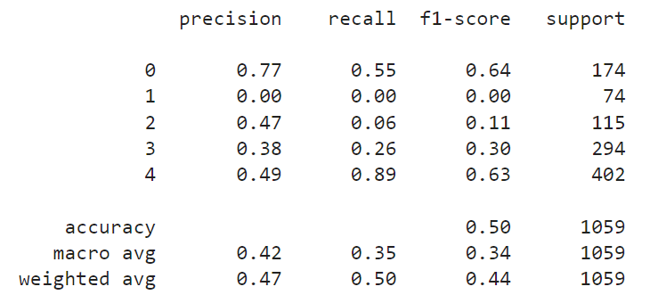

1. *Classification report before reducing classes*

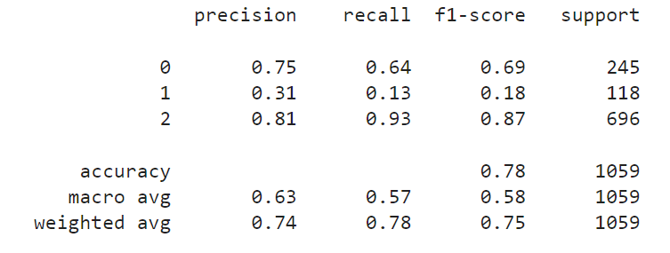

1. *Classification report after reducing classes and minority sampling with CountVectorzer*

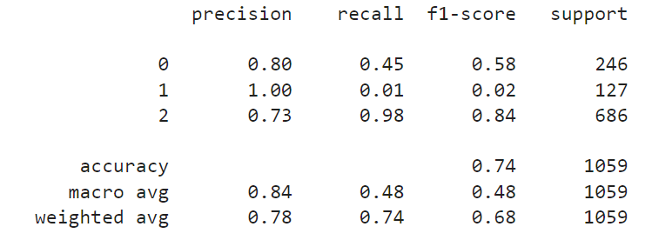

1. *Classification report after reducing classes and minority sampling with TfidfVectorizer*

## Machine Learning – Modelling

After inferencing the sentiment analysis model, we were left with the following dataset:

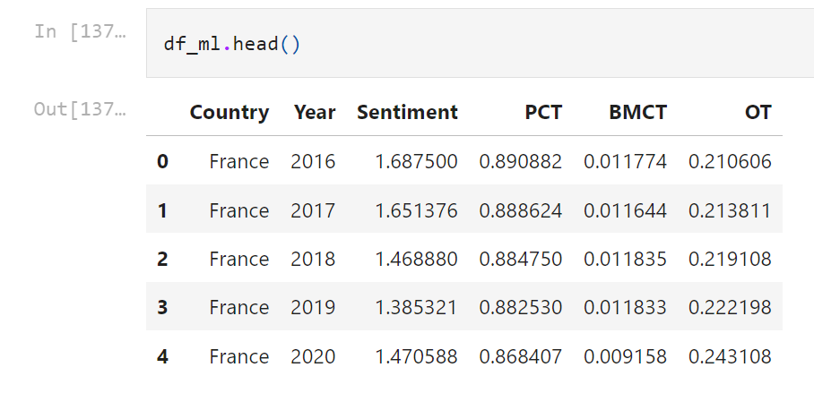

1. *Dataset ready for ML*

***Linear Regression modelling***

*Linear regression analysis is used to predict the value of a variable based on the value of another variable. The variable you want to predict is called the dependent variable. The variable you are using to predict the other variable's value is called the independent variable. (IBM, 2022)*

Before splitting the data between training and test, we selected dependent and independent variables. Also, the country feature is encoded to make sure that it could be used as a valuable information during the training:

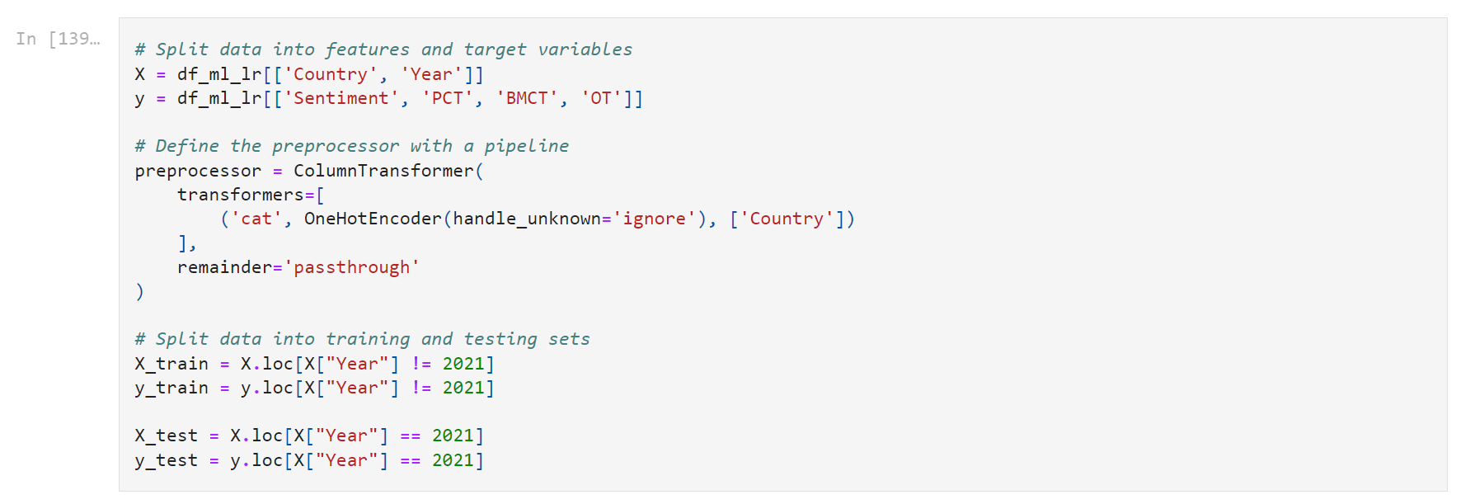

1. *Dataset preparation for Linear Regression*

Now that the data is ready, with all data before 2021 as training data and the remaining as test data, a first linear regression model is built:

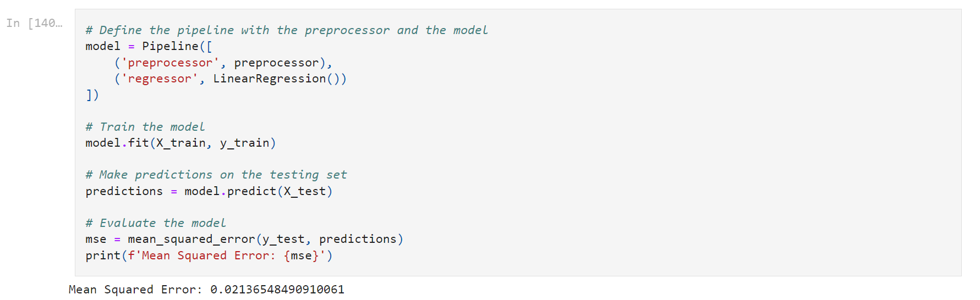

1. *Simple Linear Regression modelling*

The reason why MSE was chosen as evaluation metric is because we are dealing with very small values and this metric is very sensitive to errors. In fact, squaring the differences between predicted and actual values amplifies the impact of larger errors.

From the very first model we see that we got quite good results with an MSE of about 0.02.

Trying to improve this result, we applied cross validation technique with GridSearchCV to fit_intercept and n_jobs:

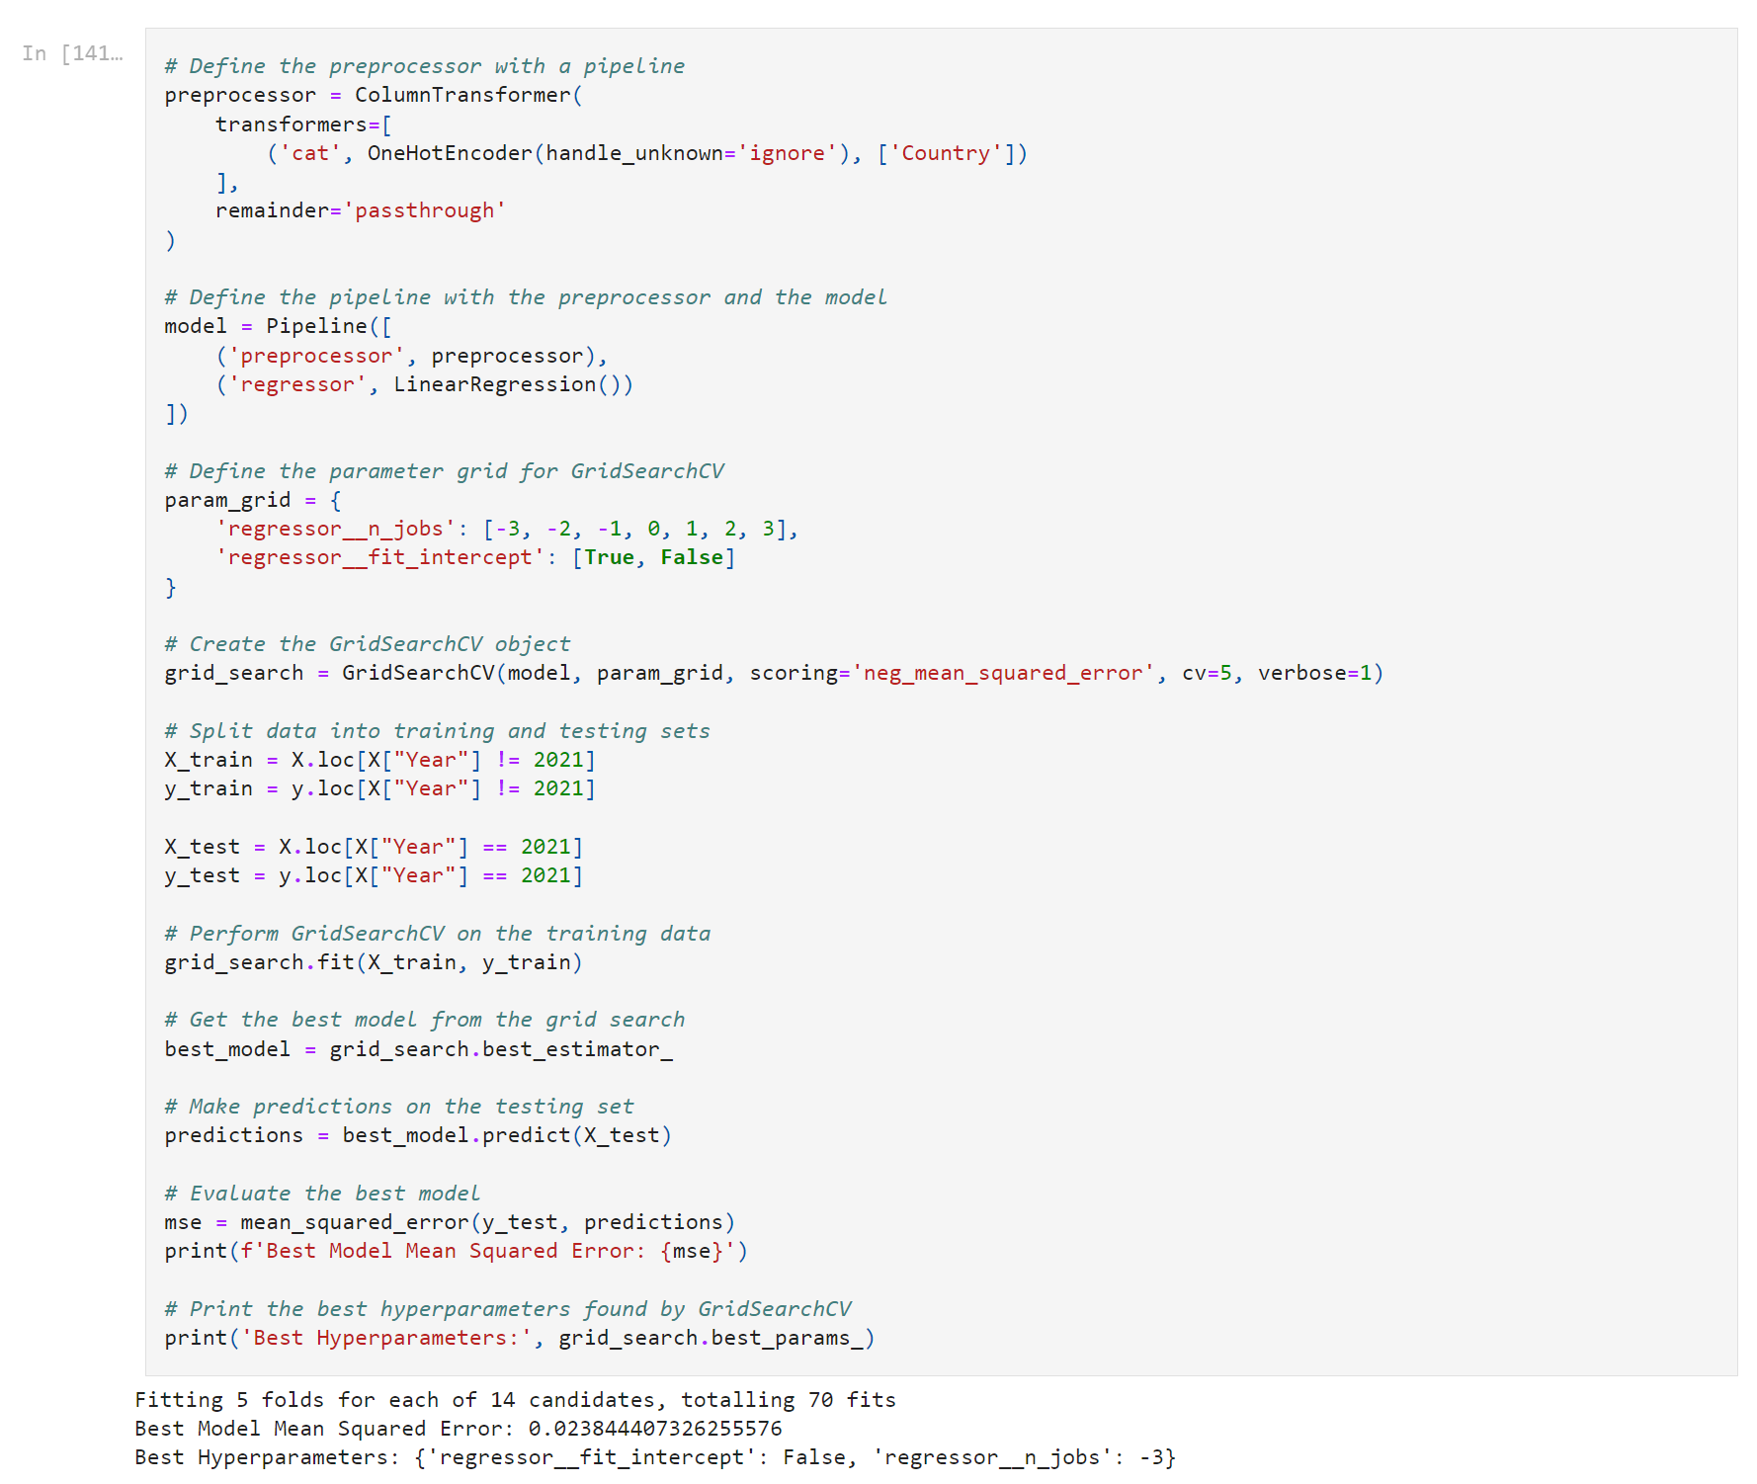

1. *Linear Regression modelling with hyperparameters tuning*

As linear regression models don’t have many hyperparameters to tune, we get an MSE very similar to the previous one.

***LSTM modelling***

*Long Short-Term Memory (LSTM) networks are a type of recurrent neural network capable of learning order dependence in sequence prediction problems. (Brownlee J., 2017)*

Before building a specific NN such as an LSTM, a simple DNN is built:

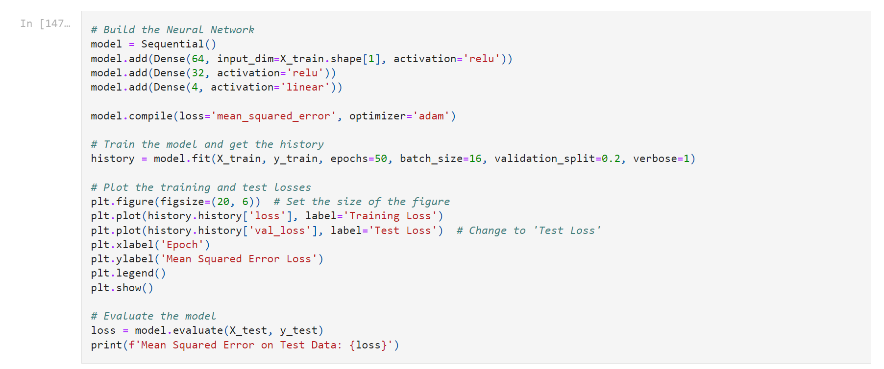

1. *Simple Dense Neural Network modelling*

From the following graph we can see that we have no significant overfitting but it’s clear that the MSE got worse by a magnitude of 10x with respect to the Linear Regression model:

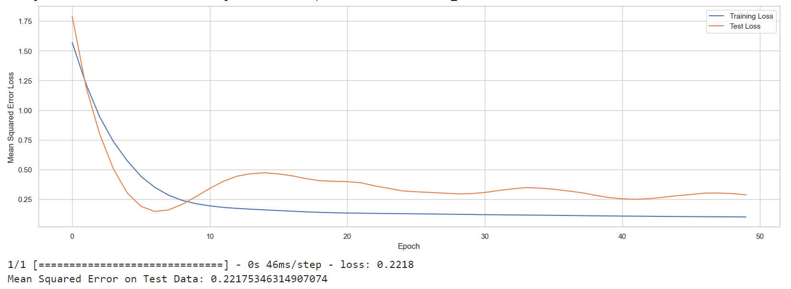

1. *Simple Dense Neural Network loss graph*

If we now build a model using an LSTM we get:

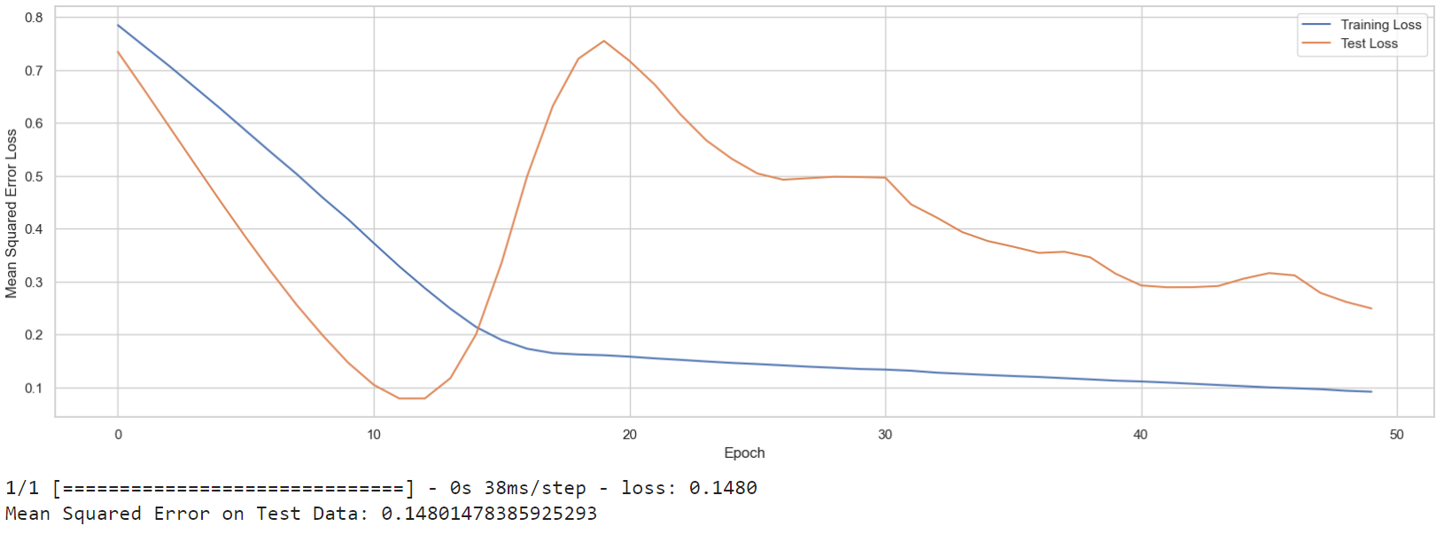

1. *Simple LSTM loss graph*

The graphs shows again that we don’t have sign of overfitting or underfitting but it’s evident that a higher epoch could have led to better results.

MSE is now reduced but still way worse than the Linear Regression one.

We thus proceed in finetuning this model using the following hyperparameters:

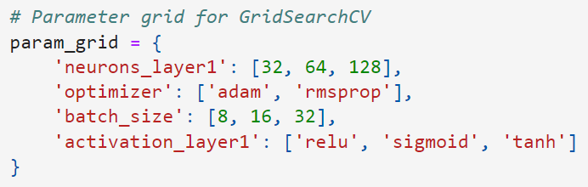

1. *Hyperparameters tuned for LSTM modelling*

This is the best model and, again, results are just way worse from the LR ones:

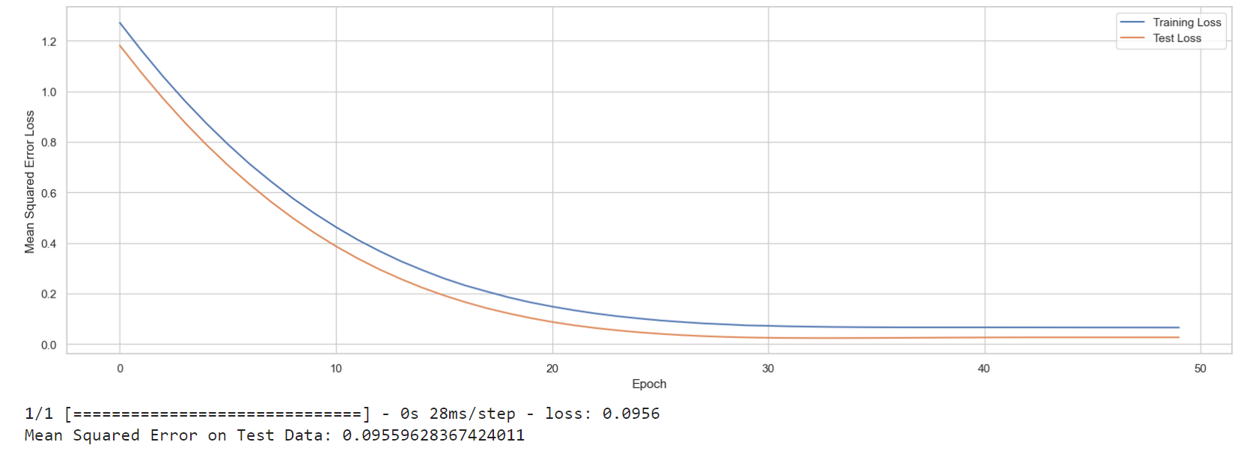

1. *LSTM with hyperparameters tuning loss graph*

## Machine Learning – Evaluation and comparison

Following table shows MSE results from different models:

|  |  |
| --- | --- |
| **Model Name** | **MSE Score** |
| Linear Regression | 0.021 |
| Linear Regression with tuning | 0.024 |
| Dense Neural Network | 0.222 |
| Long short-term memory | 0.148 |
| Long short-term memory with tuning | 0.096 |

1. *MSE score table comparison for different models*

The first LR model have a very low MSE, suggesting that it provides a good fit to the data, and its predictions are close to the actual values.

This could indicate that a simple linear relationship is a good approximation for the underlying patterns in the data.

In fact, if we look at more complex models such as DNN and LSTM, MSE is getting worse. This suggests that the complexity introduced by the neural network architecture might not be well-suited for the patterns in the data.

To better visualize how the best two models perform against the test data (traffic metric of countries with to Ireland in 2021), we can see the following plots:

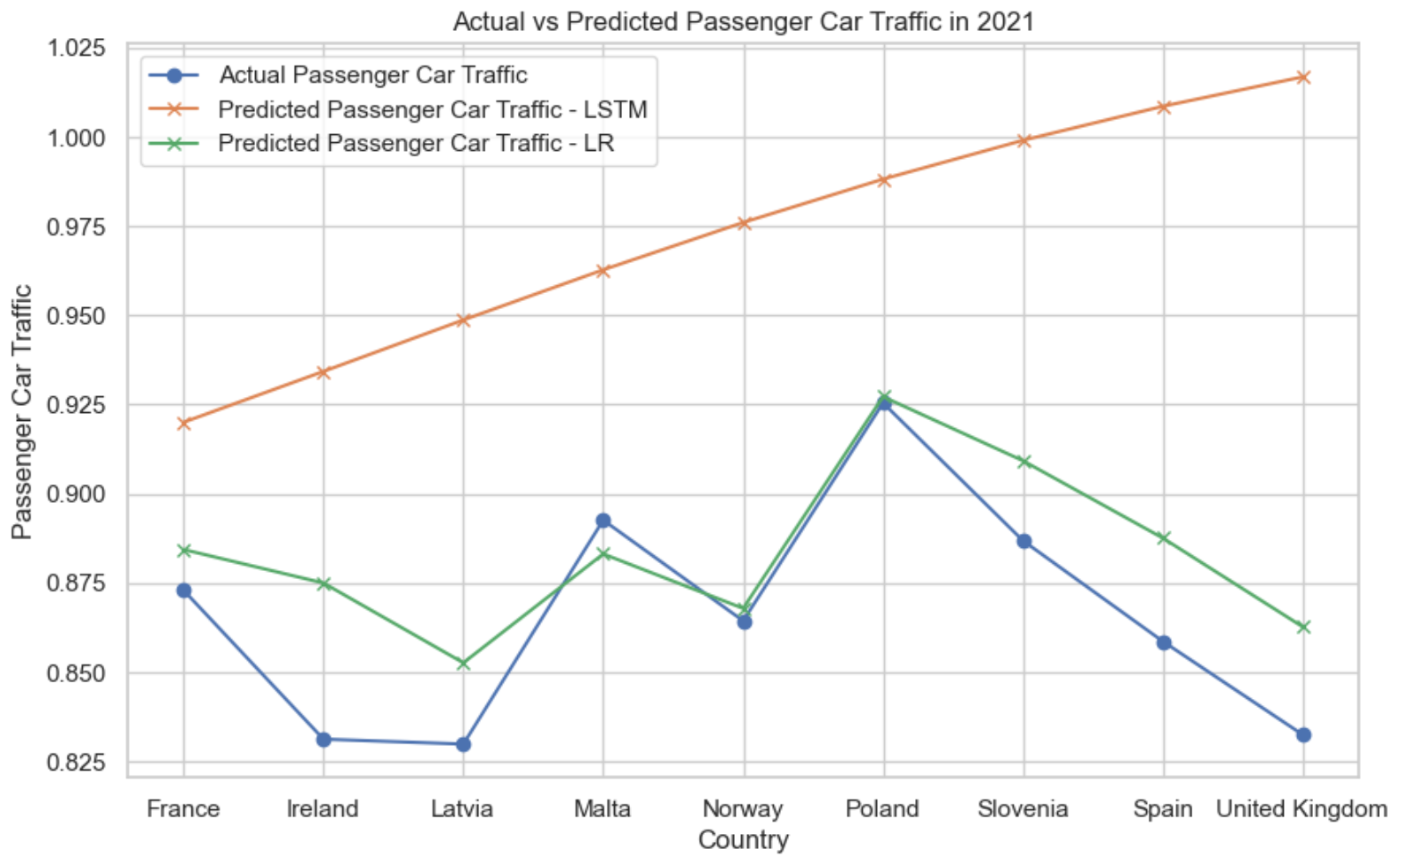

1. *Actual vs predicted passenger car traffic in 2021 for best LR and LSTM models*

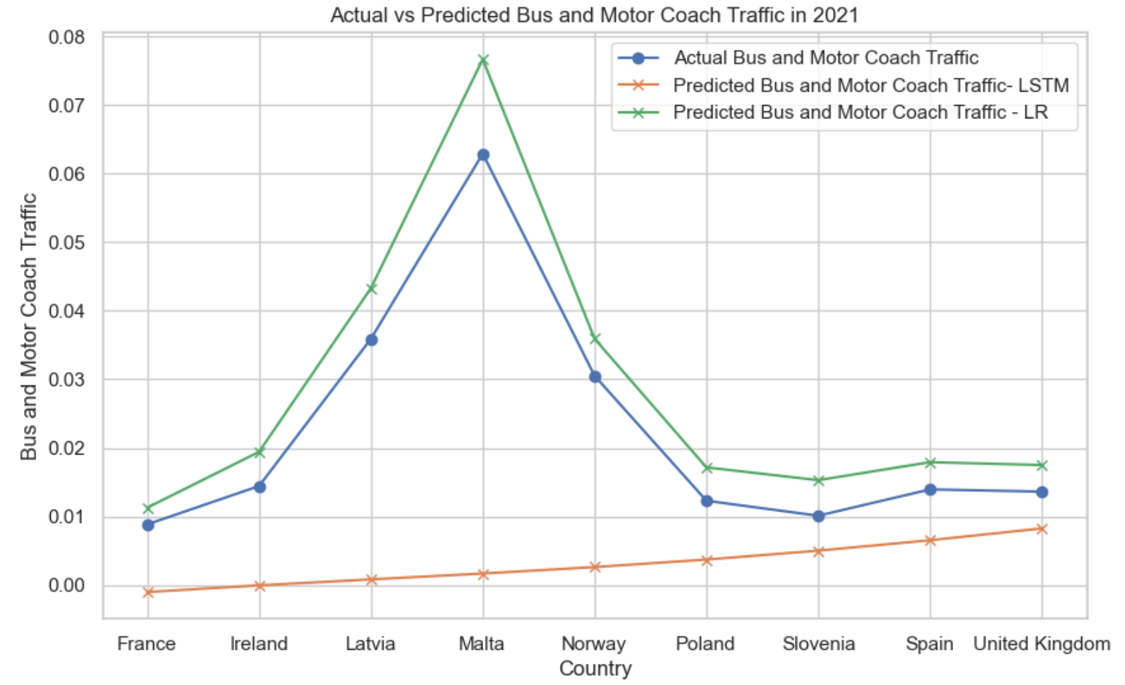

1. *Actual vs predicted bus and motor coach traffic in 2021 for best LR and LSTM models*

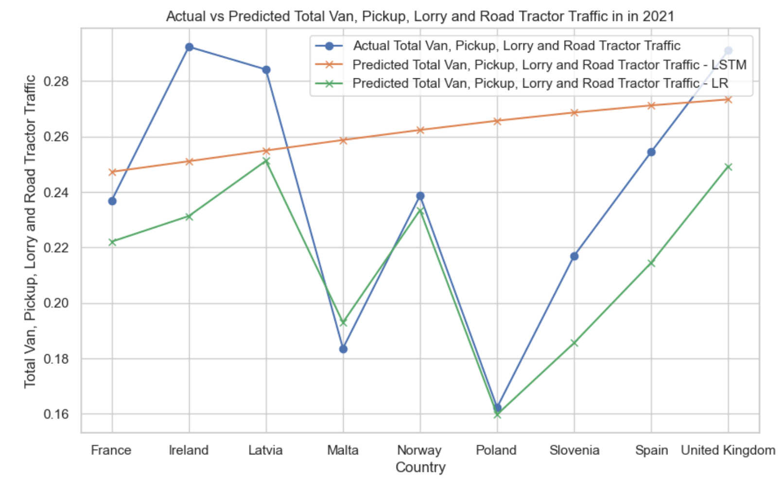

1. *Actual vs predicted total van, pickup, lorry and road tractor traffic in 2021 for best LR and LSTM models*

There are two thing that can be immediately seen.

First thing is that, for a given country, the sum of the metrics must not go beyond 1 as it means that the traffic would be higher than 100%. The LSTM is violating this rule.

Second thing is that the LSTM is just a straight line, while the Linear Regression tries to find the pattern of the actual values.

Reason why LSTM might perform poorly is because, other than its unnecessary complexity, we tried to generalize too much the problem by just giving country and year as training feature.

## Data Preparation & Visualisation – Interactive Dashboard

Following Tuft’s principles, we have ensured that the Streamlit dashboard is not only aesthetically pleasing but also functional and easy to interpret.

The very first section available is the one that allows the user to cross-filter between countries, years, and traffic metrics. This allows the user to dynamically change visuals based on needs. A checkbox is available to allow the viewer to only focus on countries like Ireland according to the study.

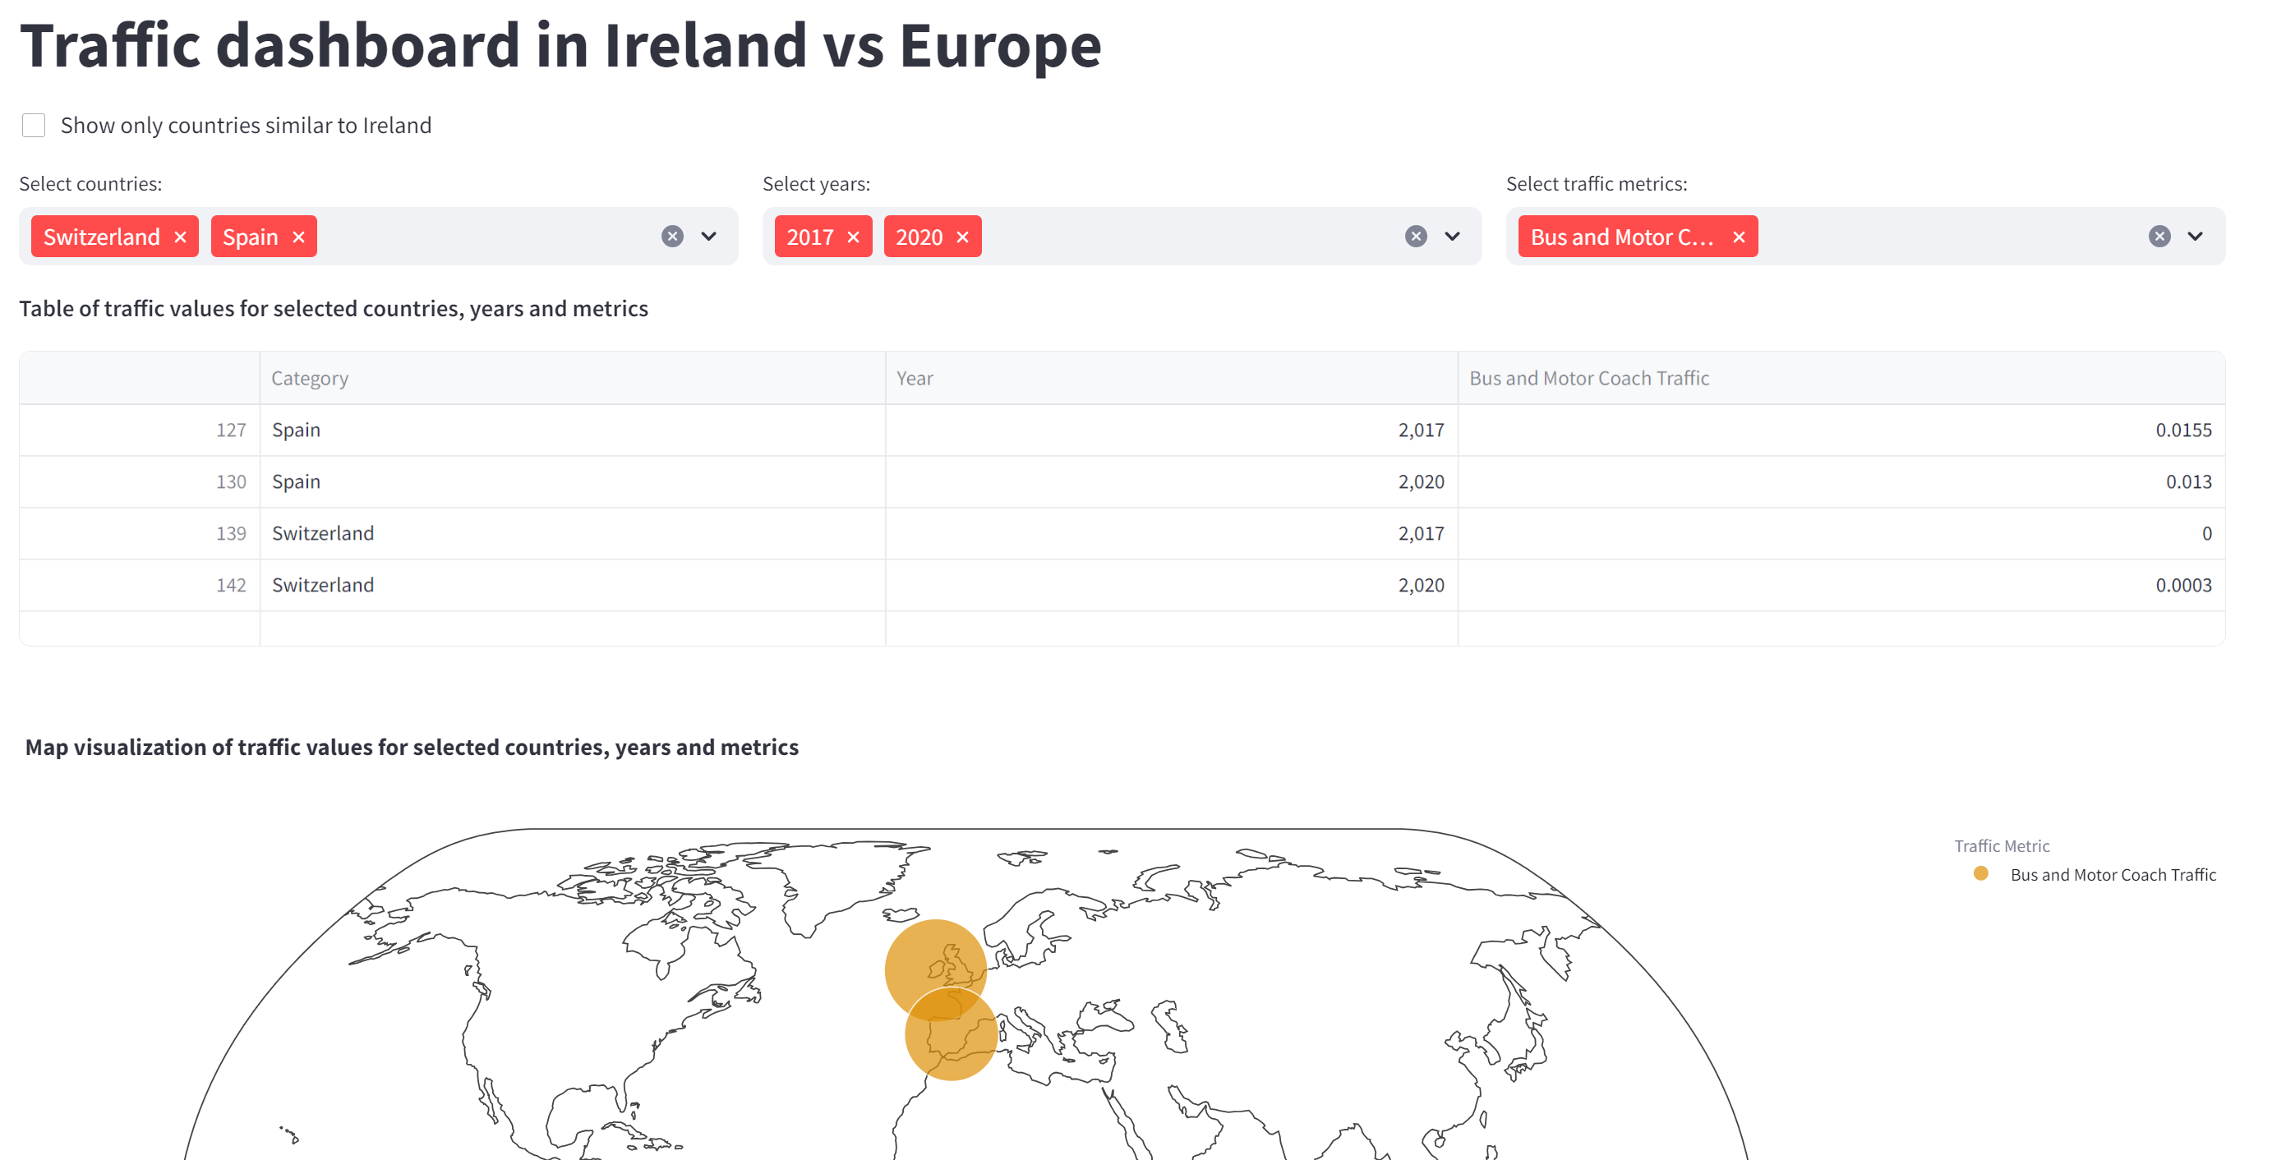

1. *Dashboard with applied filters*

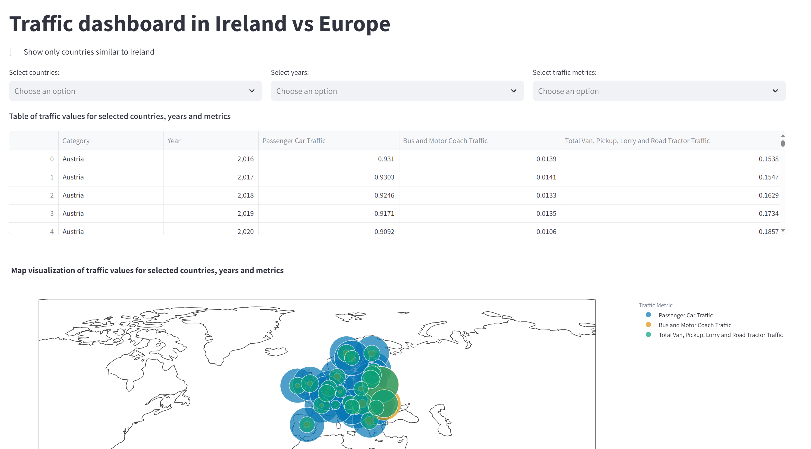

1. *Dashboard without applied filters*

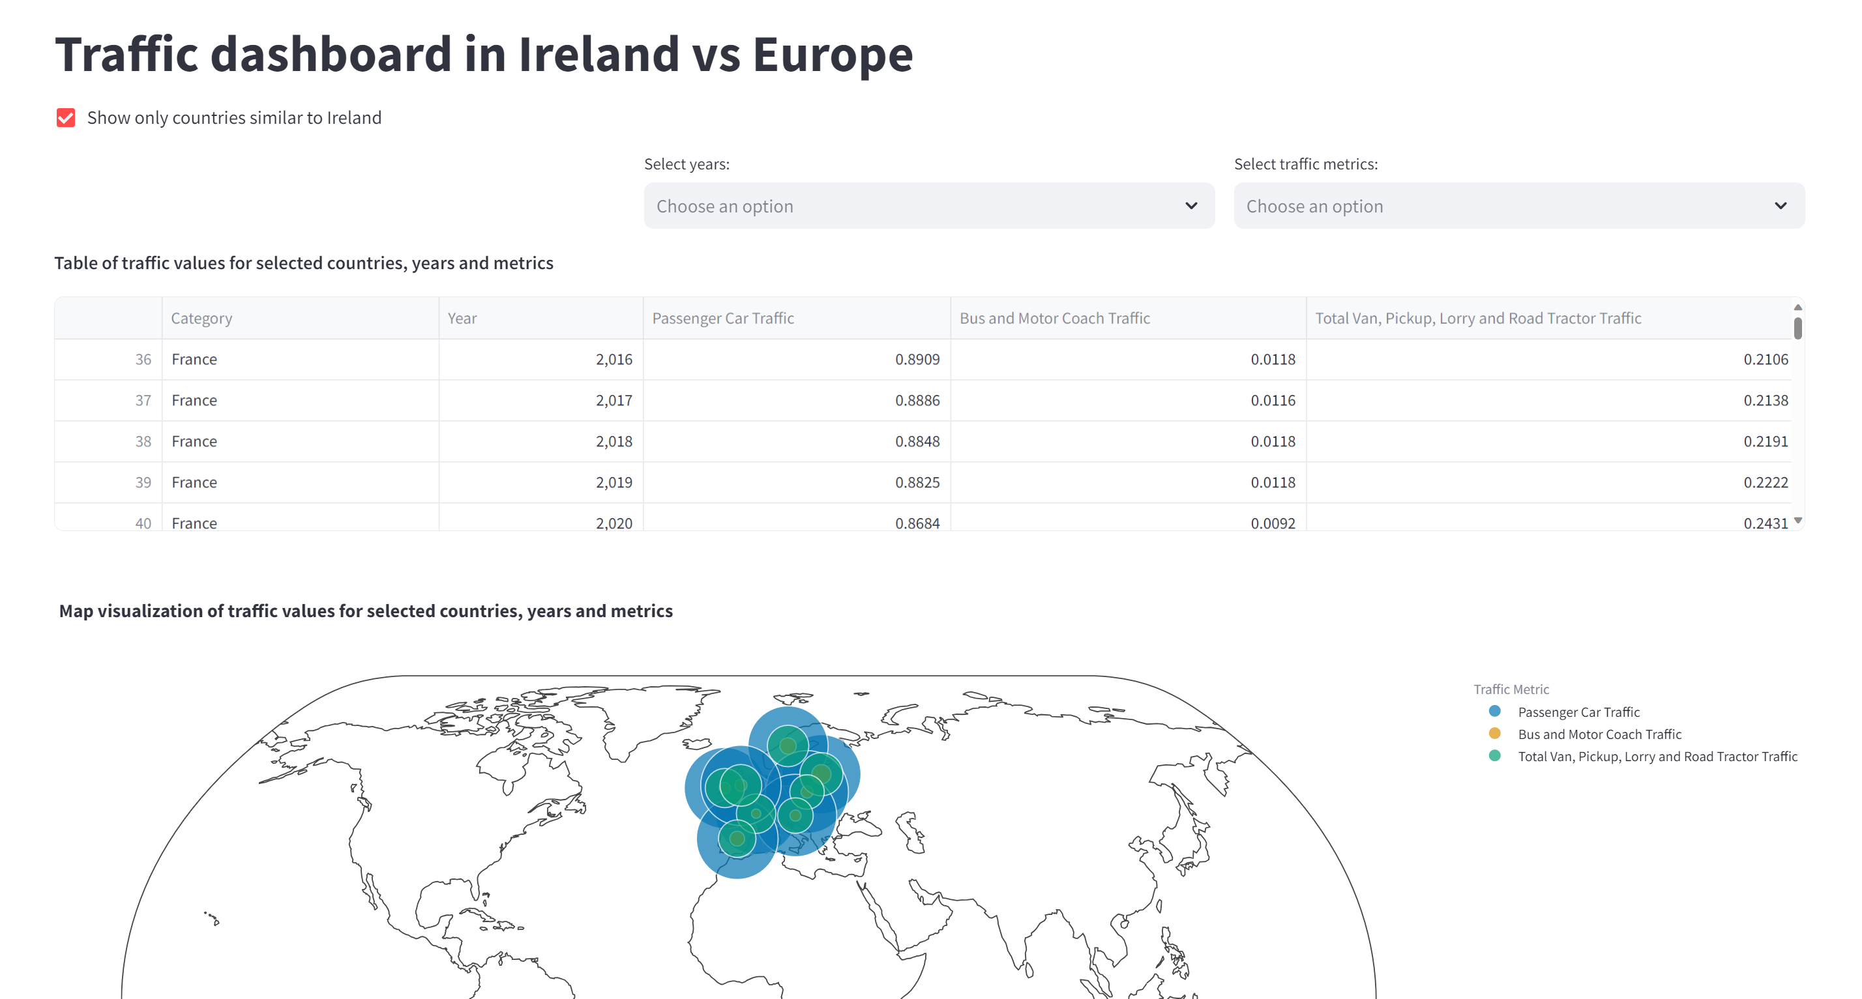

1. *Dashboard with “Show only countries similar to Ireland” checkbox applied*

A world map highlights traffic data in Ireland and Europe with an interactive slider to see evolution through years. This geographical representation aids in immediate visual comprehension and comparison across regions. Circles dimension relates to traffic volume, offering an intuitive understanding of high-traffic areas.

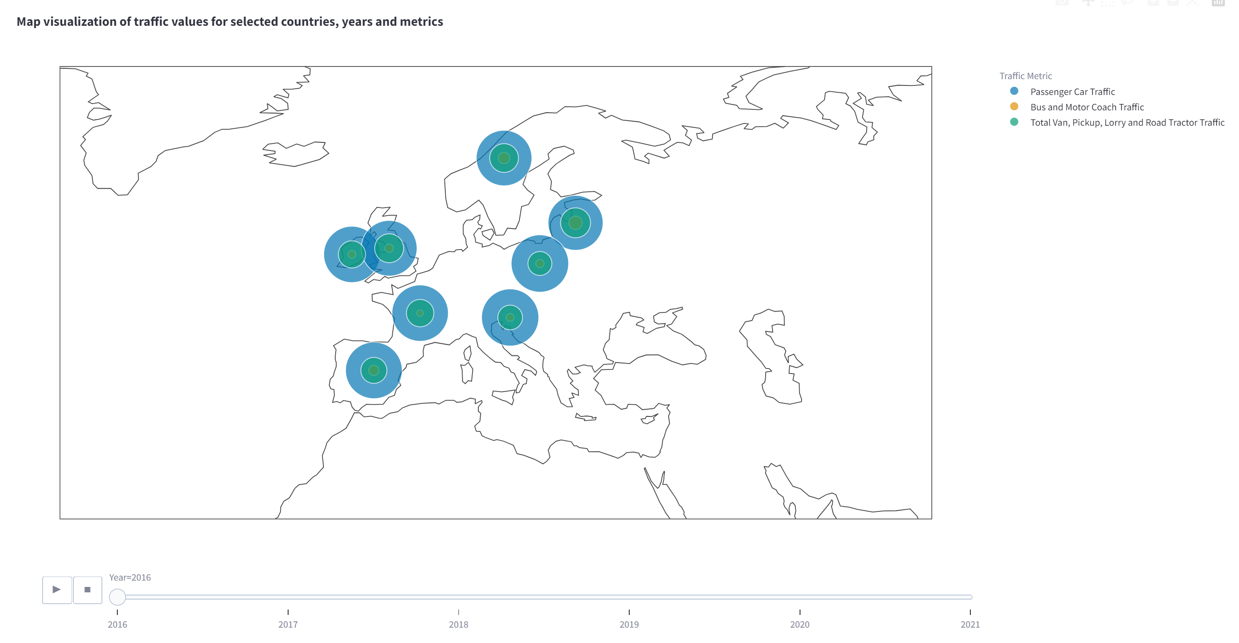

1. *Dashboard with map visualization*

Colours of traffic metrics are kept across different visualizations to allow the viewer to easily relate. Complementary colour on the colour wheel were selected to create contrast and focal points.

Below the map, “Traffic Metric Comparison” chart provides a comparison between Ireland (always plotted in red to drive attention) and selected countries. Bar graph was selected thanks to its effectiveness in displaying categorical data.

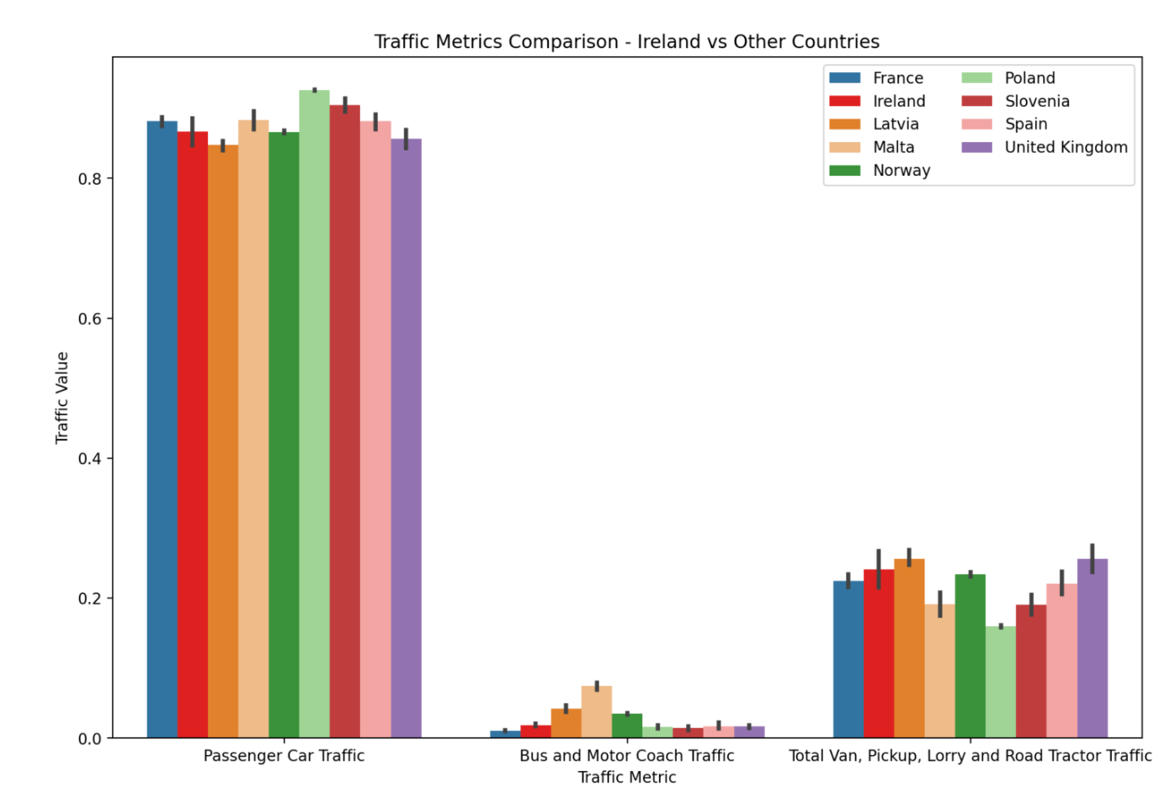

1. *Dashboard with traffic metric comparison visualization*

On the right, a line graph is used to showcase Ireland traffic trends over time. If a specific year is selected, a dotted red line appears to get viewer attention.

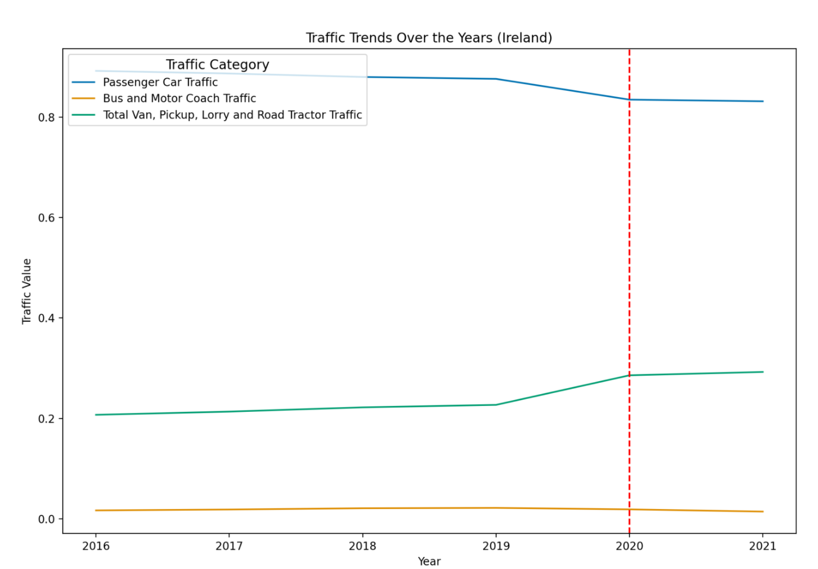

1. *Dashboard with traffic trends over the years visualization and 2020 as selected year*

Three graphs show results of the trained ML models. Each graph is representing predicted and actual values for a specific metric. Shades of the colours of that metric and different line types allow us to distinguish between actual and predicted model values.

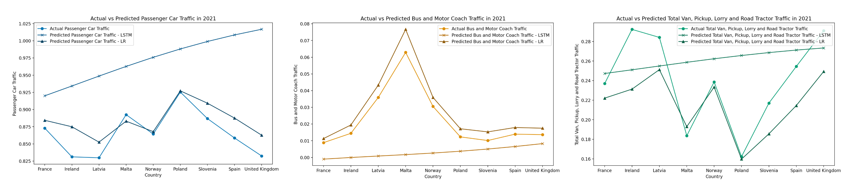

1. *Dashboard with actual vs predicted values for LSTM and LR models*

To support the exploration of the data, tables of the traffic metric dataset and user reviews are also shown.

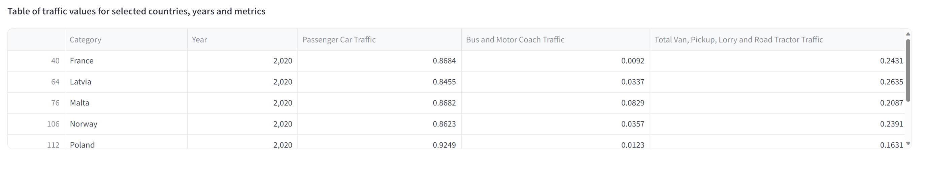

1. *Dashboard with traffic metric table*

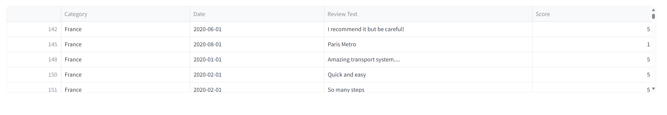

1. *Dashboard with user reviews table*

In adherence with Tuft’s principles, chart-junk was minimized ensuring that every element on the dashboard serves a purpose. The clean layout enhances readability while interactive elements enable users to delve deeper for granular insights.

This ensures that stakeholders can easily interpret complex data, facilitating informed decision-making processes rooted in evidence-based insights.

## Reference List

Official Website of the International Road Federation (IRF ). (n.d.). Who we are. [online] Available at: <https://irfnet.ch/who-we-are/>.

World Road Statistics. (2020). General Terms & Conditions. [online] Available at: <https://worldroadstatistics.org/general-terms-conditions/>.

World Road Statistics definitions. (n.d.). Available at: <https://worldroadstatistics.org/wp-content/uploads/2020/08/WRS-Definitions.pdf>.

Firdose, T. (2023). Filling missing values with Mean and Median. [online] Medium. Available at: <https://tahera-firdose.medium.com/filling-missing-values-with-mean-and-median-76635d55c1bc>.

scikit-learn (2019). sklearn.preprocessing.MinMaxScaler — scikit-learn 0.22.1 documentation. [online] Scikit-learn.org. Available at: <https://scikit-learn.org/stable/modules/generated/sklearn.preprocessing.MinMaxScaler.html>.

Mcleod, S. (2019). What Does a Box Plot Tell You? [online] Simplypsychology.org. Available at: <https://www.simplypsychology.org/boxplots.html>.

Bevans, R. (2020). Confidence Interval | Definition, Formulas, Examples. [online] Scribbr. Available at: <https://www.scribbr.com/statistics/confidence-interval/>

Bevans, R. (2020). An introduction to t tests | Definitions, formula and examples. [online] Scribbr. Available at: <https://www.scribbr.com/statistics/t-test/>.

Zach (2020). Ljung-Box Test: Definition + Example. [online] Statology. Available at: <https://www.statology.org/ljung-box-test/>.

‌Malato, G. (2023). An Introduction to the Shapiro-Wilk Test for Normality | Built In. [online] builtin.com. Available at: <https://builtin.com/data-science/shapiro-wilk-test>.

Statistics LibreTexts. (2016). 11.7: Test of a Single Variance. [online] Available at: <https://stats.libretexts.org/Bookshelves/Introductory_Statistics/Introductory_Statistics_%28OpenStax%29/11%3A_The_Chi-Square_Distribution/11.07%3A_Test_of_a_Single_Variance>,

Bevans, R. (2020). One-way ANOVA | When and How to Use It (With Examples). [online] Scribbr. Available at: <https://www.scribbr.com/statistics/one-way-anova/>.

Bevans, R. (2020). Two-way ANOVA | When and How to Use it, With Examples. [online] Scribbr. Available at: <https://www.scribbr.com/statistics/two-way-anova/>.

Zach (2019). Kruskal-Wallis Test: Definition, Formula, and Example. [online] Statology. Available at: <https://www.statology.org/kruskal-wallis-test/>.

‌Hayes, A. (2019). How the Wilcoxon Test Is Used. [online] Investopedia. Available at: <https://www.investopedia.com/terms/w/wilcoxon-test.asp>.

‌Brownlee, J. (2020). Random Oversampling and Undersampling for Imbalanced Classification. [online] Machine Learning Mastery. Available at: <https://machinelearningmastery.com/random-oversampling-and-undersampling-for-imbalanced-classification/>.

Scikit-learn (2018). sklearn.feature_extraction.text.CountVectorizer — scikit-learn 0.20.3 Documentation. [online] Scikit-learn.org. Available at: <https://scikit-learn.org/stable/modules/generated/sklearn.feature_extraction.text.CountVectorizer.html>.

‌Scikit learn (2018). sklearn.feature_extraction.text.TfidfVectorizer — scikit-learn 0.20.3 documentation. [online] Scikit-learn.org. Available at: <https://scikit-learn.org/stable/modules/generated/sklearn.feature_extraction.text.TfidfVectorizer.html>.

‌IBM (2022). About Linear Regression | IBM. [online] www.ibm.com. Available at: <https://www.ibm.com/topics/linear-regression#:~:text=Resources->.

Brownlee, J. (2017). A Gentle Introduction to Long Short-Term Memory Networks by the Experts. [online] Machine Learning Mastery. Available at: <https://machinelearningmastery.com/gentle-introduction-long-short-term-memory-networks-experts/>.